**DESIGN AND FABRICATION OF PARALLEL MANIPULATOR 3-UPS, 1-UPU JOINT**

**A PROJECT REPORT**

***Submitted by***

**ASHIQ RAHMAN A (2018111015)**

**LOGESH KUMAR B (2018111063)**

**RAJASHANMUGAM R R (2018111087)**

**VIGNESHWARAN E (2018111130)**

***in partial fulfilment for the award of the degree***

***of***

**BACHELOR OF ENGINEERING**

***in***

**MECHANICAL ENGINEERING**



**COLLEGE OF ENGINEERING GUINDY**

**ANNA UNIVERSITY: CHENNAI 600 025**

**JUNE 2022**

**ANNA UNIVERSITY: CHENNAI 600025**

**BONA FIDE CERTIFICATE**

Certified that this project report **“DESIGN AND FABRICATION OF PARALLEL MANIPULATOR (3-UPS, 1-UPU JOINT)”** is the bona fide work of

“**ASHIQ RAHMAN A 2018111015**

**LOGESH KUMAR B 2018111063**

**RAJASHANMUGAM R R 2018111087**

**VIGNESHWARAN E 2018111130**

who carried out the project work under my supervision.

**SIGNATURE SIGNATURE**

**Dr. S. BALASIVANANDHA PRABU Dr. A. ELAYAPERUMAL**

**Head Of the Department Professor**

Department of Mechanical Engineering

College of Engineering, Guindy College of Engineering, Guindy

Anna University Anna University

Chennai 600025 Chennai 600025

**ABSTRACT**

This is the era of automation where every field is trying to automate the tasks. Robots are one of the key structures used in automation. A robot may be defined as a machine that performs various complex and often repetitive tasks; guided by automatic controls. Industries are the areas where automation is geared up to increase productivity within a given time.

Parallel manipulators are robots composed of multiple closed kinematic loops. Typically, these kinematic loops are formed by two or more kinematic chains that connect a moving platform to a base. This kinematic structure allows parallel manipulators to be driven by actuators positioned on or near the base of the manipulator. It is very compact and has high rigidity and strength, hence can be used in very tight spaces more effectively.

# ACKNOWLEDGEMENT

We are highly indebted to our guide **Dr. A. ELAYAPERUMAL,** professor, Engineering Design Division, Department of Mechanical Engineering, College of Engineering Guindy, Anna University for his useful suggestion, moral support, sustained interests, and encouragement throughout the project.

We consider it a privilege to thank **DR. S. BALASIVANANTHA PRABU** Professor and Head, Department of Mechanical Engineering, College of Engineering Guindy, Anna University, for providing facilities for the successful completion of the Project.

We sincerely thank our Project coordinator **Dr. K. MALAR MOHAN**, Assistant professor (SI Gr), Department of Mechanical Engineering, College of Engineering Guindy, Anna University, for providing us with all facilities for the project.

We are extremely grateful to our review committee members **Dr. G. SHIBU,** Assistant Professor, Department of Mechanical engineering, **Mrs. N. MUTHUMEKALA,** Assistant Professor, Department of Mechanical engineering, and **Dr. E. RAJASEKARAN**, Teaching fellow, Department of Mechanical Engineering, College of Engineering Guindy, Anna University, for the valuable suggestions for this project.

Ashiq Rahman A Logesh Kumar B Rajashanmugam R R Vigneswaran E

2018111015 2018111063 2018111087 2018111130

**TABLE OF CONTENTS**

**CHAPTER NO. TITLE PAGE NO.**

**ABSTRACT iii**

**ACKNOWLEDGEMENT iv**

**LIST OF TABLES viii**

**LIST OF FIGURES ix**

**LIST OF SYMBOLS xi**

**1. INTRODUCTION 12**

1.1 OVERVIEW 12

1.2 AIMS AND OBJECTIVE 13

1.3 LITERATURE SURVEY 14

1.4 METHODOLOGY 15

1.4.1 Robotics 15

1.4.2 Mechanical Design 16

1.4.3 Optimization 17

**2. BRIEFING OF PARALLEL MANIPULATOR 18**

2.1 INTRODUCTION 18

2.2 TYPES OF MANIPULATORS 19

2.3 REQUIREMENTS 20

**3. ROBOTICS 23**

3.1 INVERSE KINEMATICS 23

3.2 ITERATIVE PROCESS 30

3.2 WORKSPACE ANALYSIS 35

3.3 CONTROL OF ACTUATORS 38

3.4 SENSORS USED 38

3.4.1 Limit Switches 38

3.4.2 Endocer 39

3.5 PID CONTROL 40

3.6 USER INTERFACE 43

3.6.1 Keyboard Control to Remote control 43

3.7 LOOKING INSIDE THE BLACK BOX 45

**4. DESIGNING PHASE 46**

4.1 DESIGN CONSIDERATIONS 46

4.2 SELECTION OF DRIVE 47

4.3 SELECTION OF MOTOR 50

4.3.1 Prismatic Actuator Motor 50

4.3.2 Revolute Actuator Motor 51

4.4 DESIGN PARAMETERS 53

4.5 FINAL CAD MODEL 55

**5. ANALYSIS AND SIMULATION PHASE 57**

5.1 VALIDATION OF CHOSEN 57

CONFIGURATION

5.2 FINITE ELEMENT ANALYSIS 58

5.3 MESH DETAILS 59

5.4 ANALYSIS OF COMPONENTS 60

5.4.1 UV-Joint Sub assembly 61

5.4.2 X-Tilting Sub assembly 62

5.4.3 Y-Tilting Sub assembly 63

5.4.4 Actuator Sub assembly 64

5.4.5 Base plate Sub assembly 65

**6. FABRICATION PHASE 67**

6.1 MANUFACTURING TECHNIQUES 67

6.2 ASSEMBLY TECHNIQUES 68

6.3 FABRICATION MODEL 69

**7. RESULT AND CONCLUSION 71**

**REFERENCES 73**

**LIST OF TABLES**

|  |  |  |  |
| --- | --- | --- | --- |
| **TABLE NO** | **TITLE** | **PAGE**  **NO** | |
| 3.1 | Specifications of the encoder | 40 |
| 3.2 | keys for bot control | 44 |
| 4.1 | Lead screw parameters (input) | 48 |
| 4.2 | Lead screw parameters (load) | 49 |
| 4.3 | 3 Motor parameters (output) | 49 |
| 4.4 | Design parameters of the parallel manipulator | 53 |

**LIST OF FIGURES**

|  |  |  |
| --- | --- | --- |
| **FIGURE NO** | **TITLE** | **PAGE**  **NO** |
| 1.1 | Industrial 3 link manipulator | 12 |
| 1.2 | Work Space | 15 |
| 2.1 | Parallel manipulator controlling antennas orientation | 20 |
| 2.2 | Simulator controlled by parallel manipulator | 21 |
| 2.3 | Portrait-drawing delta robot | 22 |
| 3.1 | Code for inverse kinematics | 27 |
| 3.2 | Code visualization | 29 |
| 3.3 | 1st iteration | 31 |
| 3.4 | 2nd iteration | 31 |
| 3.5 | 3rd iteration | 32 |
| 3.6 | 5th iteration | 32 |
| 3.7 | 6th iteration | 33 |
| 3.8 | 7th iteration | 33 |
| 3.9 | 8th iteration | 34 |

|  |  |  |
| --- | --- | --- |
| 3.10 | Code for workspace analysis | 36 |
| 3.11 | Workspace for stroke length of 600 mm | 37 |
| 3.12 | Workspace for stroke length of 250 mm | 37 |
| 3.13 | CAD model for Workspace (for 600 mm stroke). | 37 |
| 3.14 | OE-37 Hall Effect Two Channel Magnetic Encoder | 39 |
| 3.15 | PID control parameter graphs | 41 |
| 3.16 | Inverse Kinematics for 4 and 5 active links | 43 |
| 3.17 | Remote control with limit switches | 44 |
| 4.1 | Orange 555 Permanent magnet DC-Motor | 51 |
| 4.2 | Orange 555 Permanent magnet DC-Motor | 51 |
| 4.3 | Reverted gear train | 52 |
| 4.4 | Planetary gear train | 53 |
| 4.5 | Final CAD Assembly | 55 |
| 4.6 | Actuator sub-assembly | 55 |
| 4.7 | Gimbal sub-assembly | 56 |
| 4.8 | Platform sub-assembly | 56 |
| 5.1 | Dynamic simulation using inventor | 57 |
| 5.2 | Meshed views of UV joint | 59 |
| 5.3 | Meshed view of x-tilting bracket | 59 |
| 5.4 | Meshed view of x-tilting bracket | 59 |
| 5.5 | Meshed view of actuator | 60 |
| 5.6 | Meshed view of base plate | 60 |
| 5.7 | Mesh analysis of UV joint | 61 |
| 5.8 | Mesh analysis of x-tilting bracket | 62 |
| 5.9 | Mesh analysis of Y-tilting bracket | 63 |
| 5.10 | Mesh analysis of actuator sub-assembly | 64 |
| 6.1 | Prototype 1 | 69 |
| 6.2 | Prototype 2 | 69 |

**LIST OF SYMBOLS**

UPU Universal Prismatic Universal ( sequence of joints). UPS Universal Prismatic Spherical ( sequence of joints). DOF Degree of Freedom.

Rz  Yaw.

Ry Pitch.

Rx  Roll.

PID Proportional Integral and Derivative Control. UV Universal Joint

**CHAPTER 1 INTRODUCTION**

**1.1. OVERVIEW:**

This project aims to develop a parallel manipulator with 4 links (3 Universal prismatic spherical and 1 Universal prismatic Universal joints) that are actuated via a program module. It aims to develop and analyse the model with a payload of 0.25 kg with reliability.

Industries are the areas where automation is geared up to increase productivity within a given time. One such industry is the photovoltaic ( PV) industry. The global photovoltaic (PV) manufacturing community is on the verge of a resurgence in investment, development, and innovation, a revolution that largely will be driven by technology. Robotic automation is a significant part of solar cell manufacturing. One of the tasks in the PV industry is to mount solar cells on a supportive base made up of glass or any other substrate with gentle handling. This process can be done by using parallel manipulators. Mechanical systems that allow a rigid body (called end effector) to move concerning a fixed base frame are parallel manipulators. Parallel manipulators are robots composed of multiple closed kinematic loops. 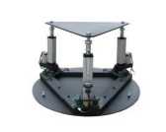

**Figure 1.1 Industrial 3 link manipulator**

**1.2. AIMS AND OBJECTIVES:**

* To design each chain to be short, simple, and can thus be rigid against the unwanted movement, compared to a serial manipulator.
* To reduce the number of links by validating each iteration.
* To validate the design and correct them using Topology Optimization.
* To conduct various analysis studies on all the components of the manipulator to investigate the failure locations.
* To reduce the number of links by validating each iteration.
* Deriving Inverse Kinematics for the current configuration.
* Force and moment at the individual links are aimed to be calculated in real-time.
* To design a base plate where actuators and electrical accessories can be located.
* To be designed in a compact with high rigidity and strength hence can be used in very tight spaces more effectively and with a high degree of safety.
* To consolidate the design suitable for manufacturing by additive manufacturing process (3D Printing) with the material PLA(polylactic acid or polylactide).
* To design a code that controls the actuators automatically through inverse kinematics.
* To design a model that lifts a payload capacity of 0.250 kg.

**1.2. LITERATURE SURVEY:**

Andreas Aristiton and Joan Lasenby (2009) published “Inverse Kinematics: a review of existing techniques and introduction of a new fast iterative solver”. It helps in developing a matrix and positioning of the end effector that helps manipulation by the code. JEAN PIERRE MERLET (2000) “Direct kinematics of parallel manipulators”. Through this paper, it identified the loops and links that help in the calculations of force and moments. Maira Martin Silva, University of Paila (2014) “Torque Optimisation of Parallel Manipulators By the Application of Kinematic Redundancy”. It is used to determine the optimisation of the design by reducing the unwanted parts in design.V.Parenti-Castelli, R.Di Gregorio and F.Bubani, Ferrara, Italy (2005) “Workspace and Optimal Design of a Pure Translation Parallel Manipulator”.It helps in understanding and achieving an optimal design that suits the fabrication. Panchanand Jha (2007), “Analysis of Robot Manipulators”. We learnt the methodology and optimization of the manipulator.

**1.3. METHODOLOGY**:

1**.3.1. ROBOTICS:**

**a). Design Of Link Lengths:**

● Link length calculations are done using the forward and inverse kinematics equations of the parallel manipulator.

● This is done to ensure the ideal link length setting for the given constraints.

**b). Estimation Of Force and Torques:**

● This is done by calculating the dynamic forces and torque that would act on the members for a given payload and designing the transmission systems and joints accordingly.

● This can be done by calculating the Jacobian matrix.

● This way is ideal to ensure that the joints designed would never have to face any forces beyond its range.

**c).Range Calculation :**

**●** Using the dynamic forces and link length as constraints the workspace and the singularities of the manipulator are calculated.

● Once the singularities are located the necessary steps are taken to avoid them in maximum cases.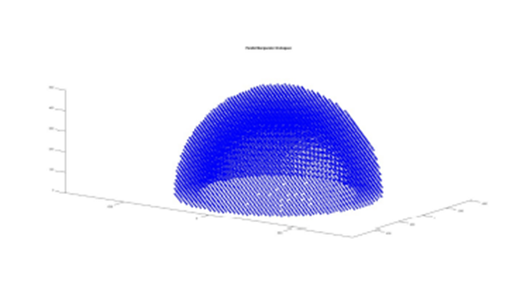

**Figure: 1.2.Work Space**

### 1.3.2. MECHANICAL DESIGN :

**a).Selection of Mechanical Drives :**

A suitable transmission system has to be selected, designed, and employed for providing actuation to the sliding and rotating joints in the Parallel Manipulator, Thus, constructing a robust robotic syst**em.**

**b).Design Considerations for Selection of the Drive System:**

Speed, High Strength, High Efficiency, Wear-Resistance(Reduction of friction), Mechanical Advantage(High reduction ratio), Reliability, Precession, Accuracy, Reduced Complexity, Ease of Assembly, Water-Proofing.

**c).Design of UV joints, Welded joints, and Threaded Fasteners:**

Selection and design of suitable UV joints, Welded joints and Threaded Fasteners.

**d).Design considerations for UV joints, Welded joints and Threaded Fasteners :**

Axial force, Radial Force, Shear Force, Bending moment, Speed of Operation, High Efficiency, Less Friction, Reliability.

**e).Design of Structural Components:**

Design of Structural components considering the von-mises (Maximum Distortion energy), Tresca (Maximum Shear stress), Rankine (Maximum Normal stress), Haigh (Maximum Strain energy) theory of failure, and selection of suitable materials as per the stresses calculated.

**f).Design Considerations for Structural Components:**

Normal Force, Shear force, Tangential Force, Torque, Bending Moment, Fatigue Stresses. Stiffness, Elastic.

**g).Selection of Motor:**

Selection of the motor based on the required Torque, Speed, Maximum Power, and Available Clearance.

## 1.3.3. OPTIMIZATION:

### Topology Optimisation using Ansys topology optimization:

The topology of the structural members of the robot is optimized considering the stresses acting, cost, reliability, and duty cycle of the member. Iteration of the design to make it easier to manufacture, economical, and ensure that the design satisfies the design consideration.

**CHAPTER 3**

## ROBOTICS

**3.1. INVERSE KINEMATICS**

The mathematical model was used to determine the joint parameters using the end effector position alone. This mathematical model is developed from a set of free-body diagrams and tested on code and CAD software. Once the respective model was checked and ensured it met all the tests it was implemented in the actuator.

Before looking into the derivation of inverse kinematics few key concepts have to be kept in mind are :

**1.Pose of a frame**

Pose refers to the position and the orientation of the frame with respect to a reference frame (Base frame). These properties are usually calculated using matrices. There are two matrices used to represent the pose of a frame

1. Rotational matrix
2. Pose matrix / vector ( displacement vector )

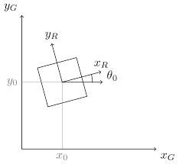

**3. Rotational Matrix**

It is used to perform a rotation about an axis or a combination of axes.

For example

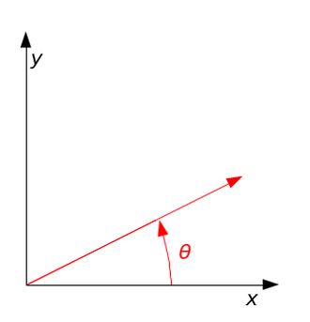

This is used to represent rotation on the X-Y plane with the angle position from the x-axis. Here the base frame is the X-Y axis. This very same concept can be extrapolated to the 3 dimensions giving rise to 3-dimensional rotational matrices.

A 3-dimensional rotational matrix about the X, and Z-axis is given by,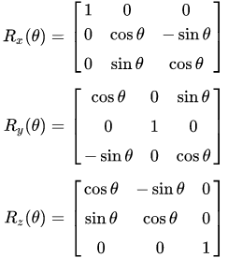

Where Rx, Ry, and Rz represent the rotational matrices about the X-axis, Y-axis, and Z-axis representatively. By combining these matrices we get the overall rotation about all the axes.

Rz = Yaw

Ry = Pitch

Rx = Roll

By multiplying the matrices in the ( Z, Y , X) following order we get the following,

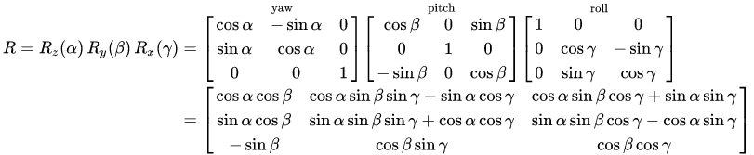

**Alpha** = rotation about z-axis

**Beta**  = rotation about y-axis

**Gamma** = rotation about x-axis

**4. Position Matrix**

The matrix is used to define the shortest distance a point has to take from one point ( origin of parent frame ) to the destination point (Child frame) provided it's constrained to move in the X-Y and Z direction alone ( parallel to the axes) as shown in the diagram.

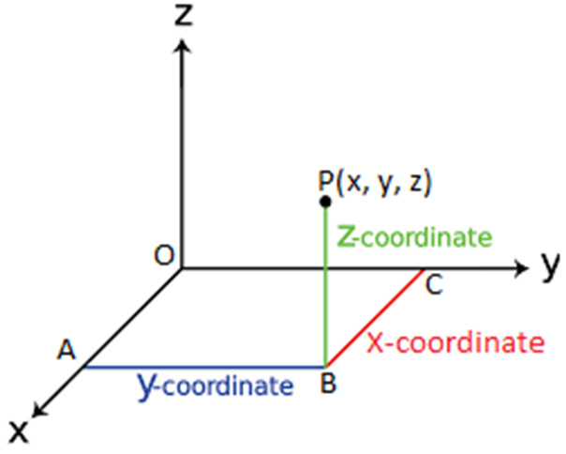

Hence the position matrix for the point P would be

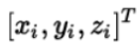

**Derivation of Inverse Kinematics:**

Now finding the inverse kinematics equations for the parallel manipulator, a 2d version was first considered. Here,

a = base platform length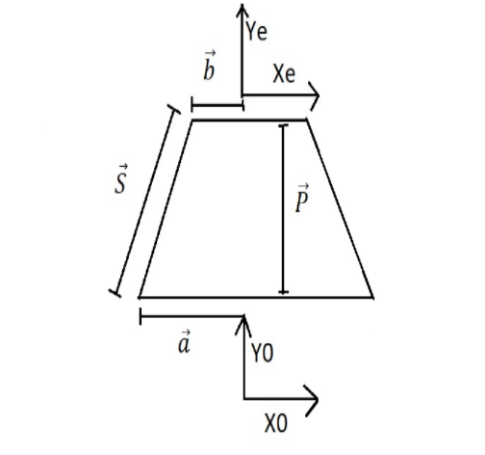

b = end effector platform length

s = link length

P = position vector.

E = end-effector frame

0 = base frame

Converting them to vector notation we get,

By solving using the formulas above we get,

a + s = p + bo

bo = R * be

Finally we get, 

S = p + R*b - a

The code snippet is as follows:

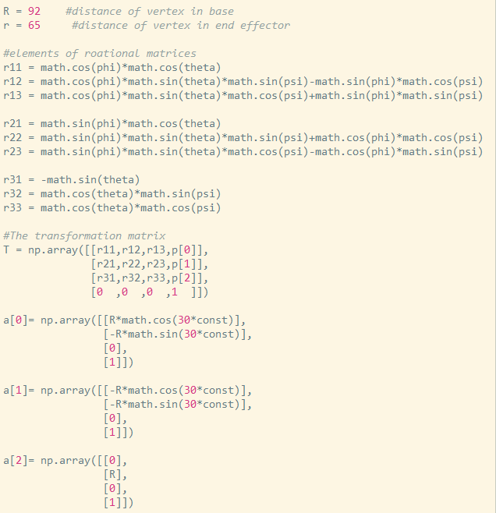

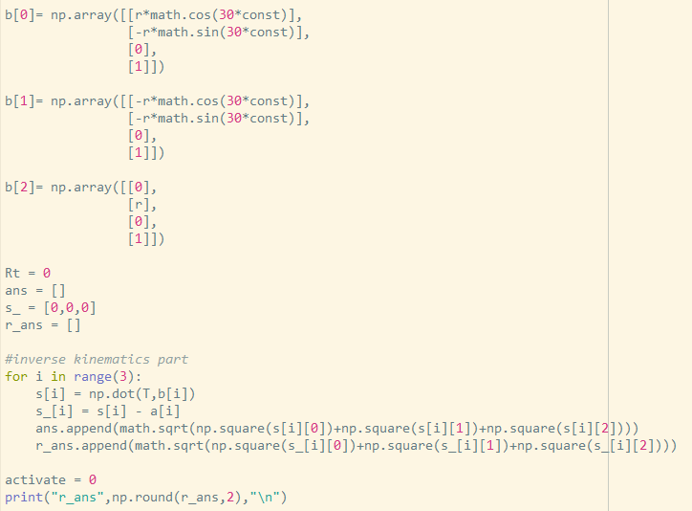

The main motive essentially is to translate the point from base to the Gimbel center point in the actual model with respect to the base. Hence the point on the base ( which is considered to be the origin) is translated 50 mm upward which is given by offdist vector (0,0,50). Finding the angle of the obtained vector with respect to the x and y-axis using cosine law gives you alpha and beta that will be used to control the gimbal angular position

The code snippet as follows: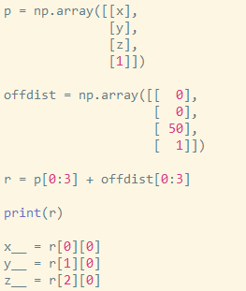

**Figure 3.1 Code for inverse kinematics** 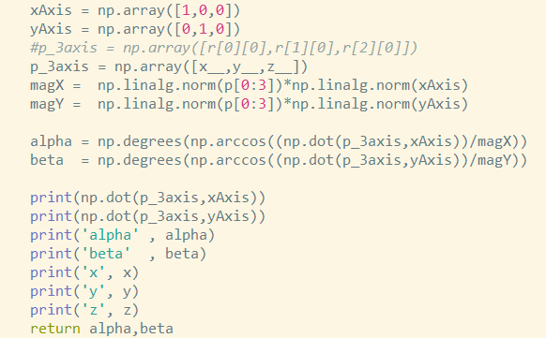

The same logic is applied for 3 dimensions and 3 links and we get the following results. X, Y, Z = -100,-100, 275

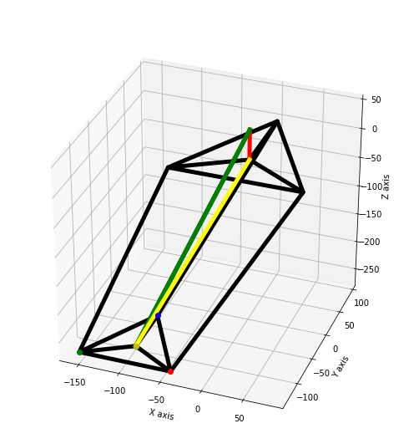

**Figure 3.2 code visualization**

**SINGULARITY**

In a simple definition, it is the part where the equation or the mathematical model can't explain or doesn't correlate well with the actual model.

Singularities in the robot are the configuration in which the robot end-effector becomes locked in certain directions or even completely, in other words, the robots get locked in to that position and would require external support to overcome the singularity.

* **Ways to tackle or solve the singularities**

In these instances, there are two ways to approach this issue:

1. To avoid the singularities by modifying the code
2. The other way would be to modify the design and solve those singularities one by one**.**

The former is the ideal way and it was chosen to solve the issue in our case.

**3.2. ITERATIVE PROCESS OF MODEL**

Initially, on designing the manipulator it was noticed that the robot would have a singularity, that is the robot could not be controlled when coming to the yaw ( rotation about the z-axis) motion.

Hence the following iterations were done to overcome the singularity and also compensate for the yaw motion an actuator was added at the end effector plate.

**3-SPS Link design - (1st iteration):**

* No reaction torque for arresting motor rotation
* No Z-axis rotational stability
* All three links are actuated by a motor
* Has 6-DOF but 1-DOF is uncontrollable (z-rotation)

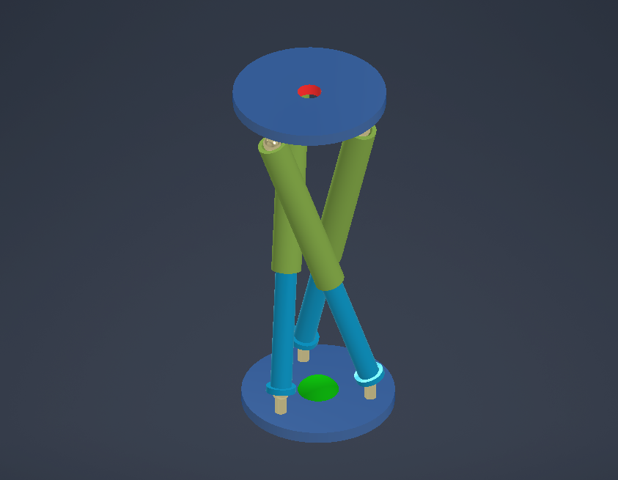

**Figure 3.3 1st Iteration**

**3-UPS Link design - (2nd iteration):**

* Due to the usage of universal joints, the reaction required for arresting the motor from rotating is obtained.
* All three links are actuated by a motor
* No Z-axis Rotational stability
* Has 6-DOF but 1-DOF is uncontrollable (z-rotation)

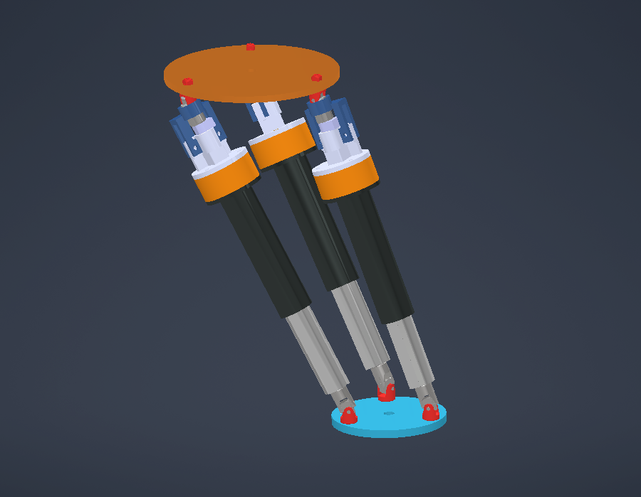

**Figure 3.4 2nd Iteration**

**3-UPS + 1-UPU Link design - (3rd iteration):**

* Has reaction torque for arresting motor rotation
* Z-axis rotational stability achieved.
* Has only 5-DOF.

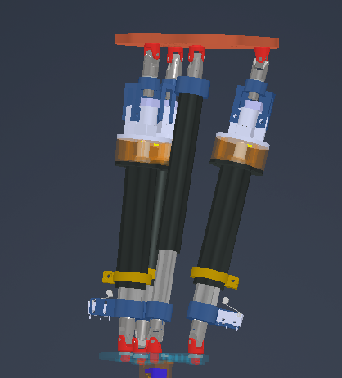

**Figure 3.5 3rd Iteration**

**3UPS + 1-UPU + Z rotary actuator Link design - (4th iteration):**

* Has 6-DOF with full control on all 6 - DOF where the yaw motion is achieved by the use of servo motors.
* Had very limited control in all the axis and a lot of play was observed

**3UPS + 1-UPU Link design - (5th iteration):**

* The centre link was made active ( prismatic)
* Despite this no improvement was observed

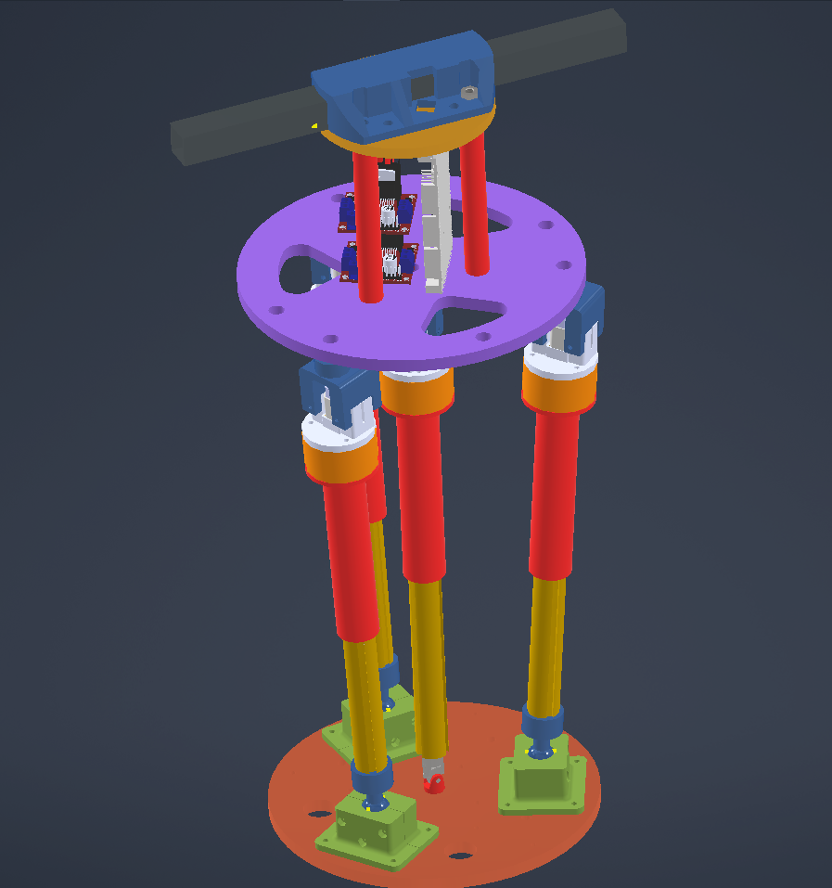

**Figure 3.6 5th Iteration**

**4UPS + 1-UPU Link design - (6th iteration):**

* Similar to the previous model with one extra UPS link
* The above model is built and checked but there wasn't any difference in or improvements in the performance of the manipulator.

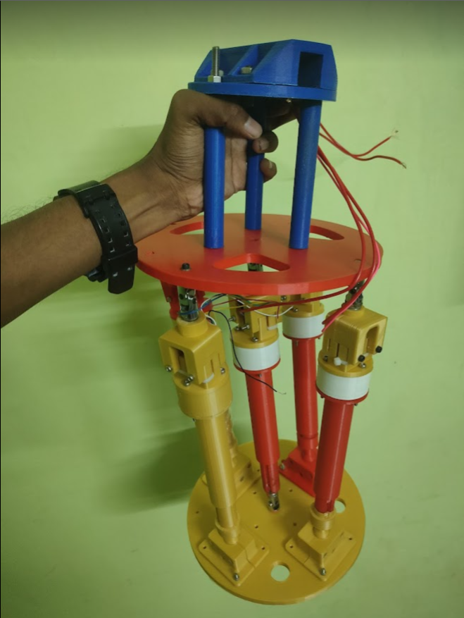

**Figure 3.7 6th Iteration**

**3UPS + 2RR Link design - (7th iteration):**

* Dialled it back down to 3 UPS links and the centre link was actuated by two rotational joints similar to a two-axis gimbal.
* This iteration couldn't be checked as building the manipulator in this configuration posed some problems.

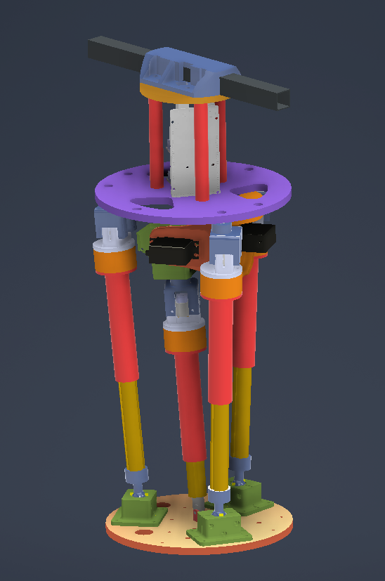

**Figure 3.8 7th Iteration**

**3UPS + 2RR Link design - (8th iteration (Final)):**

* This model was designed practically to implement the previous iteration
* The difference is that the gimbal arrangement was placed above the base platform since it wasn't practically feasible to place them in the base.

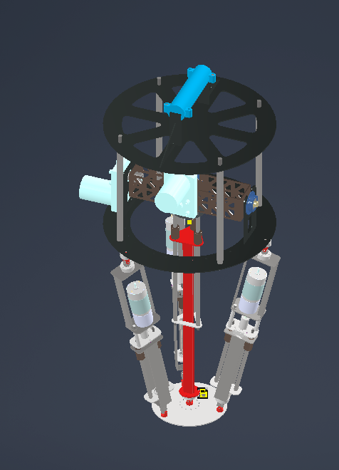

**Figure 3.9 8th Iteration**

**3.2. WORKSPACE ANALYSIS**

**Parallel Manipulator workspace analysis**

Initializing important parameters:

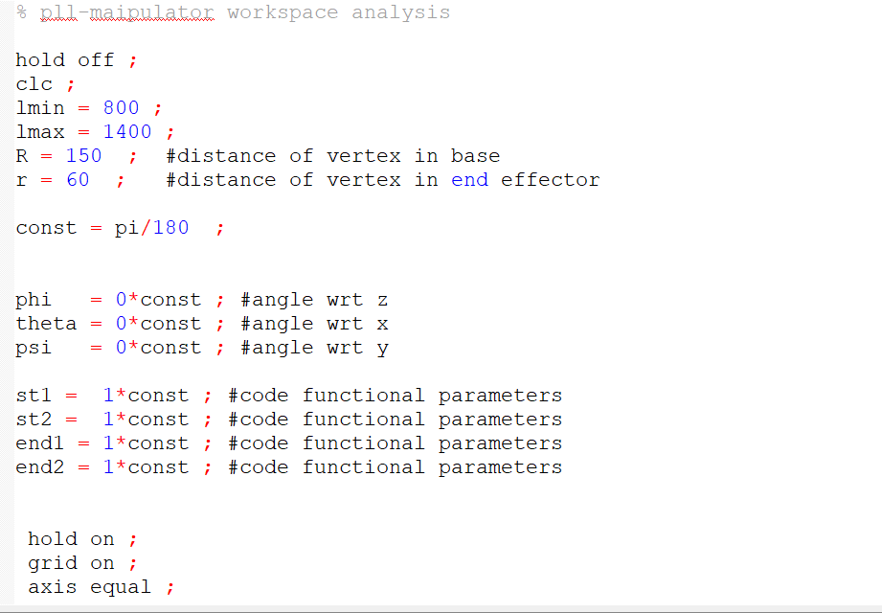

Initialization of loop and calculating the rotational matrix:

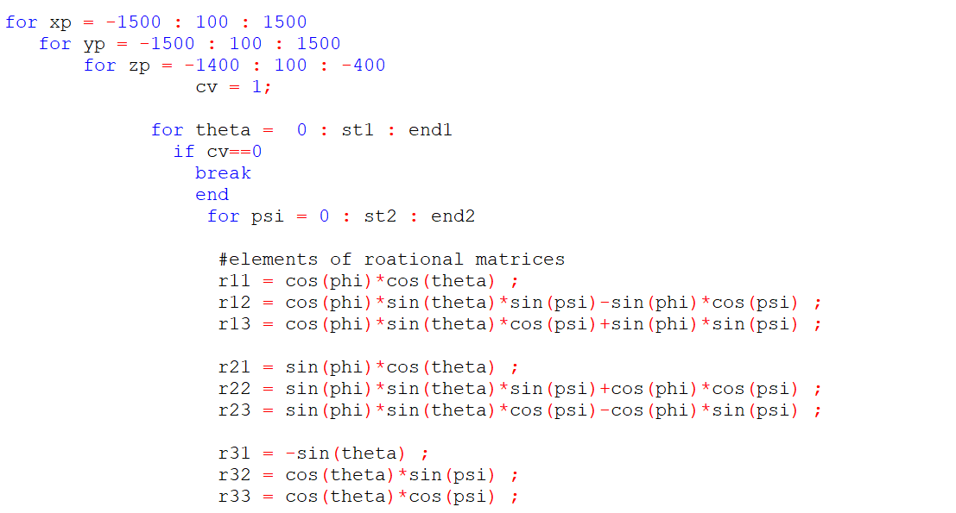

Homogenous Matrix and Inverse Kinematics calculations:

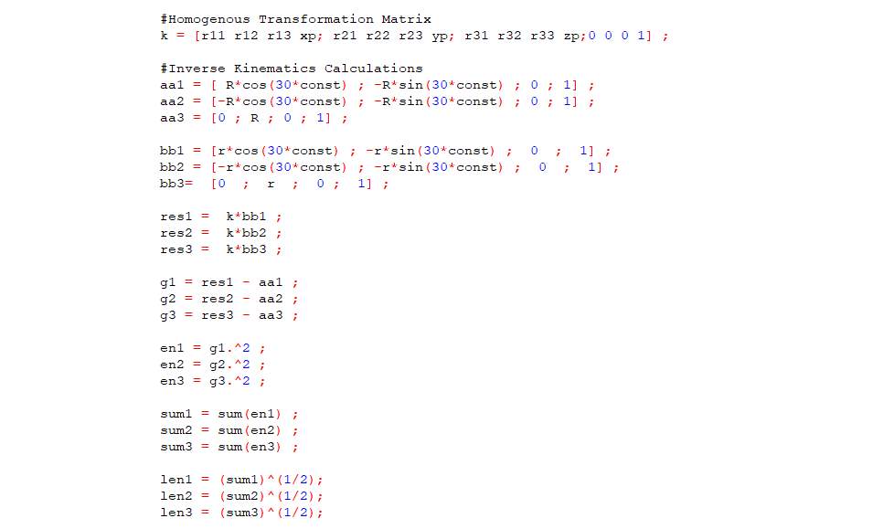

Setting limits and visualization :

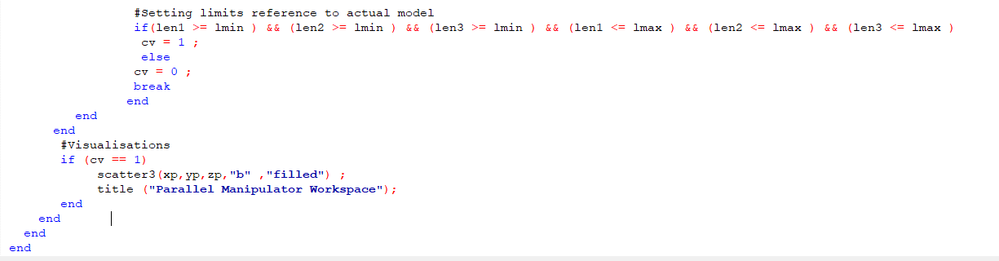

**Figure 3.10 Code for workspace analysis**

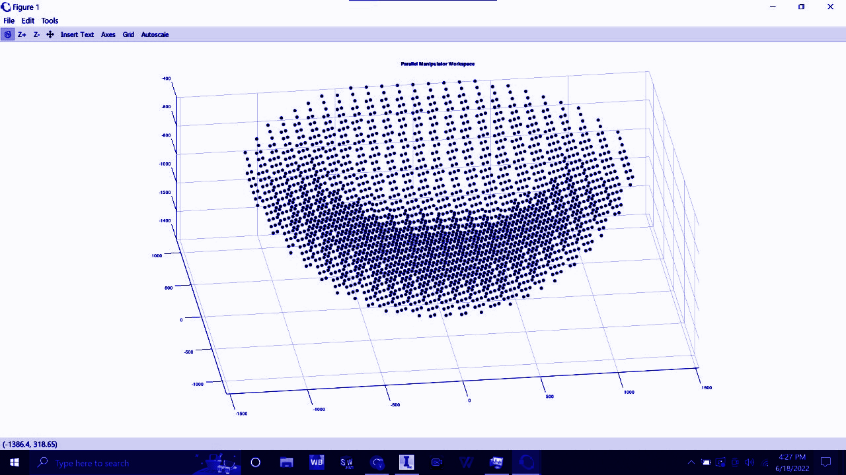

**Figure 3.11 Workspace for stroke length of 600 mm**

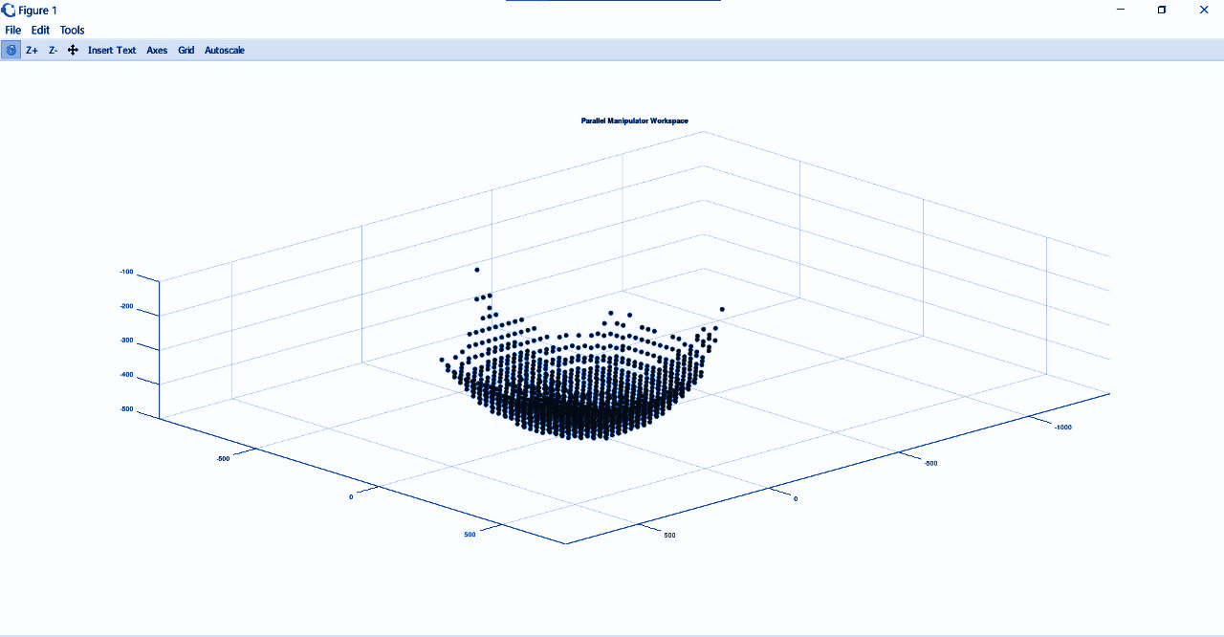

**Figure 3.12 Workspace for stroke length of 125 mm**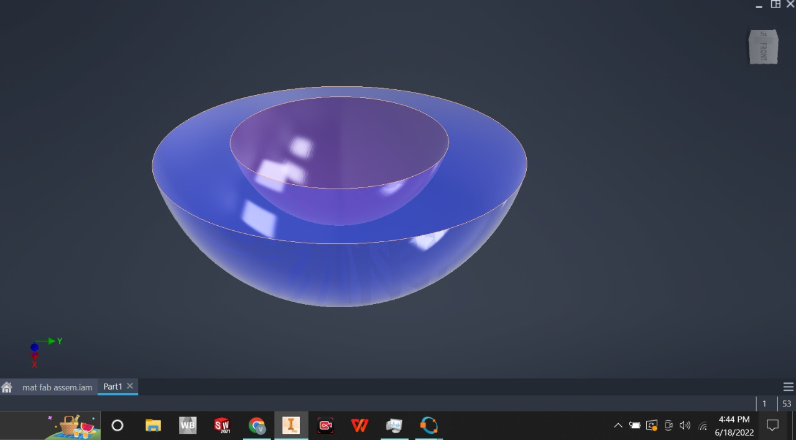

**Figure 3.13 CAD model for Workspace (for 600 mm stroke)**

**3.3. CONTROL OF ACTUATORS**

The output from the Inverse kinematics code was used to determine the actuator length and the 2-axis gimbal joint angles. This was sent to teensy which was then used to PID control to smoothly actuate the joints independently from the current position to the target position. Since the teensy had multiple interrupt pins it was able to simultaneously control all the joints successfully. The thing is the controller would be actively looking for the change in setpoint and hence would be updated every code cycle which makes the manipulator reactive to any commands given by the user.

**3.4 SENSORS USED**

Sensors are the set of components that would ready the environment and report it back to the microcontroller. Without this, it would be impossible to control the joints and we would have to Eyeball it to start and stop the actuator. This gives the risk of the actuator breaking due to human errors like driving the drive past its limits and also the manipulator wouldn't be capable of being autonomous. Hence the sensor is a necessity. The two types of sensors used in the project are Limit switches also known as end stops and Encoder.

**3.4.1. LIMIT SWITCHES**

They are used to determine the end limits of the actuators to prevent the actuators from breaking there are different ways to attach and make it work to the manipulator as follows:

* Firstly, we can take the incoming signal from the switches and write the code to stop or start the actuators as per need
* Secondly, they can attach a buzzer to the switch which would turn on to indicate the actuator has reached its limits
* Finally, we can attach the motor terminal wires to make the limit switches as the master switches to turn it on or off.

**3.4.2. ENCODER**

The encoder is the sensor that makes it possible to integrate inverse kinematics into the manipulator, it gives the live position of each joint unlike limit switches which would indicate the end position of the joints.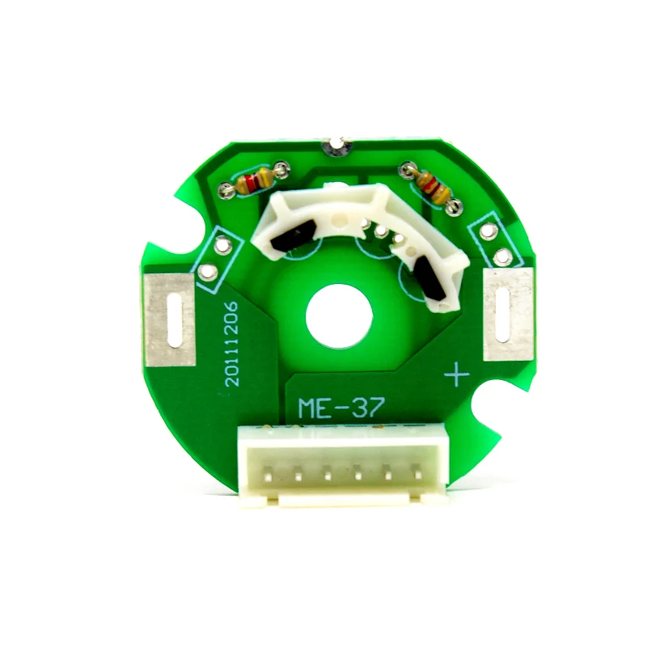

**Figure 3.14 OE-37 Hall Effect Two-Channel Magnetic Encoder**

The quadrature encoder provides a resolution of 7 counts per revolution of the motor shaft when counting both edges of both channels.

OE-37 Hall Effect Two-Channel Magnetic Encoder’s Hall sensor requires an input voltage, Vcc, between **4.5 and 24 V** and draws a maximum of 10 mA. The A and B outputs are square waves from 0 V to Vcc approximately 90° out of phase. The frequency of the transitions tells you the speed of the motor, and the order of the transitions tells you the direction.

* By counting both the rising and falling edges of both the A and B outputs, it is possible to get 7 counts per revolution of the motor shaft by both Channels.
* Encoder comes with complete accessories required to mount the encoder on the motor i.e. **plastic case, washer, magnet, connecting cable, and set of screws.**

**SPECIFICATIONS:**

**Table 3.1 : Specifications of the encoder**

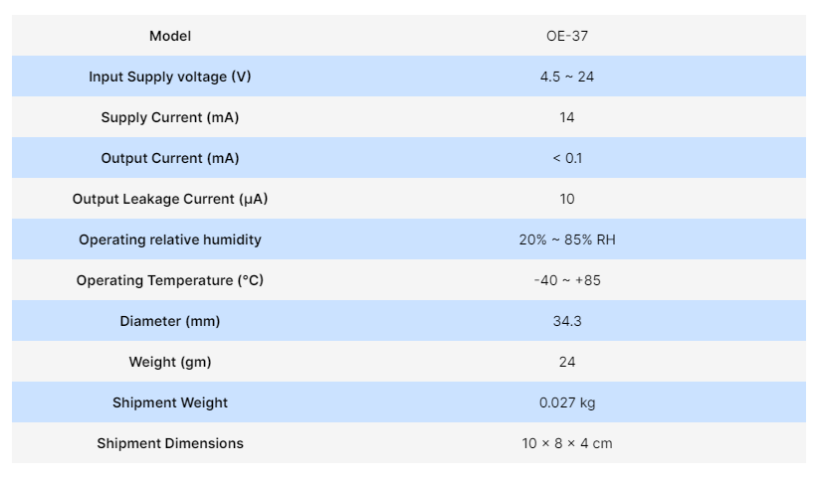

**3.5. PID CONTROLLER**

PID - Proportional Integral Derivative is a popular control system used control the joint's position and achieve the setpoint.

PID (Proportional integral and derivative control) is used to control the speed and position of the actuator to optimize the overall motion of the manipulator giving a more smooth output. The following equation is used to implement PID

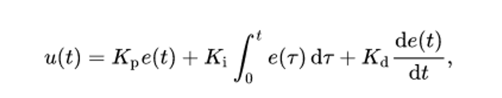

where,

Kp = proportional gain

Ki=Integral gain

Kd = derivative gain

e(t) = error as in the difference between the current input and the set position with respect to time.

The gain values are tuned manually by trial and error until the correct values are obtained. By correct values, it means that the actuator can go to the desired position ( setpoint) with little to no fluctuation in the least time possible. These gain values can also be determined by the other methods but they are computationally expensive. The usual response for an actuator with PID control would be as shown below.

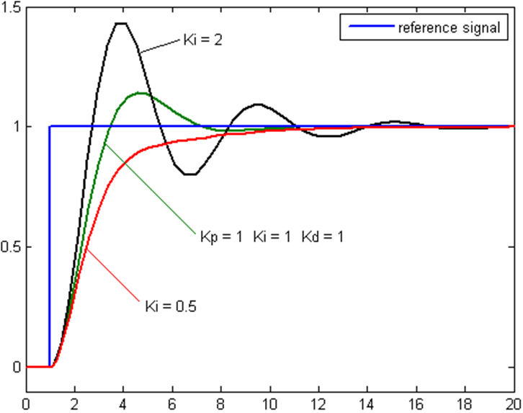

**Figure 3.15 : PID control parameter graphs**

As we can see in the diagram for different values for gains the path that the actuator takes to the setpoint is influenced. From the diagram, we can say the orange trajectory is the one with the optimal gain values.

These concepts are applied in the robot not as a whole but for each individual actuator. That is each actuator has a custom PID with its own gain values. This is done so as to control the positioning errors from the start enabling a smooth and controlled motion of the end effector.

**3.6. USER INTERFACE:**

* The user inference implies how the user will be controlling the Manipulator and the visual output it includes.
* The user will be controlling the manipulator using the laptop keyboard where keys are coded to actuate the end effector position.
* The visual output is also displayed on the systems monitor as shown below.

The scale of the output is 1:1. Hence the model is directly correlated with the output of the code and hence can be checked and verified. All this process happens in real-time.

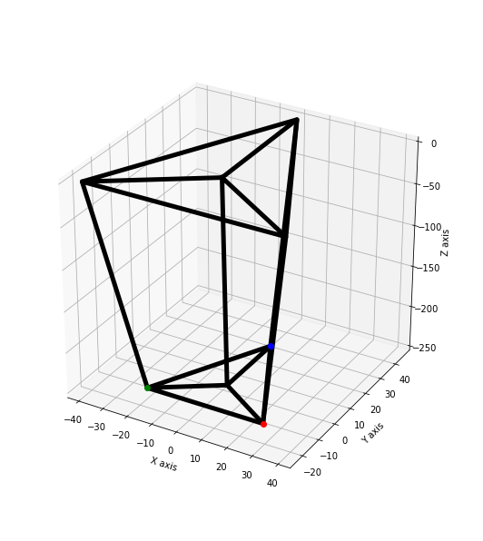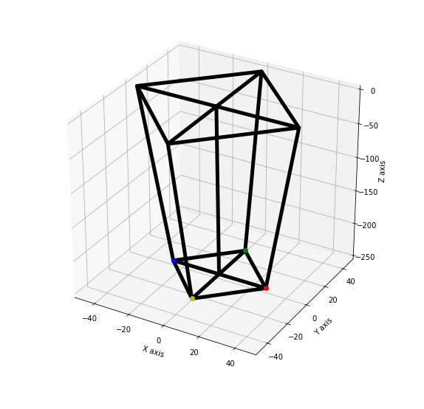

**Figure 3.16 Inverse Kinematics for 4 and 5 active links**

**3.6.1 KEYBOARD CONTROL TO REMOTE CONTROL**

Initially we used the laptop’s keyboard to control the position of

the manipulator. This was somewhat less intrusive for the user. The control

was as follows:

**Table 3.2 : keys for bot control**

|  |  |  |  |  |  |  |
| --- | --- | --- | --- | --- | --- | --- |
|  | **X axis** | **Y axis** | **Z axis** | **Rx axis (Pitch)** | **Ry axis**  **(Roll)** | **Rz axis**  **(Yaw)** |
| **Increment** | X + Up | Y + Up | Z + Up | R + X + Up | R + Y + Up | R + Y + Up |
| **Decrement** | X + Down | Y + Down | z + Down | R +X + Down | R + Y + Down | R + Y + Down |

As shown in the table above here each axis is controlled individually which is another limitation of this type of control.

Hence we had modified the laptop control to remote control, the control is as follows: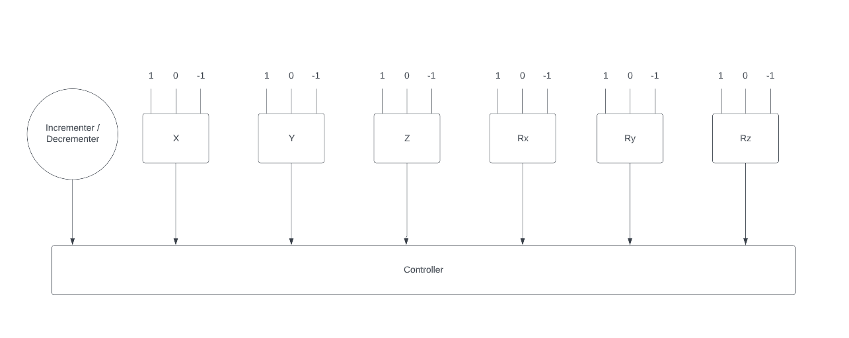

**Figure 3.17 Remote control with limit switches**

There will be 6 limit switches with a rotary encoder. Each switch has 3 states as shown in the figure.

Where - 1 - Decrement

0 - Neutral

1 - Increment

These different positions can be used to control the actuators directions(extension or retraction) and the speed of the actuation can be controlled by the rotary encoder. Provided if the power supply is rated enough to drive all the actuators all the switches can be turned on once and driven simultaneously. Hence the rating of the power source is the bottlenecking feature.

**3.7. LOOKING INSIDE THE BLACK BOX**

The inputs are the end-effector position given by the user via the keyboard keys. and the output is the motion of the parallel manipulator to achieve the end effects position. Let's break it down to see what exactly happens in the black box.

First, the inputs are taken and converted to joint parameters using inverse kinematic equations. These are solved analytically and not numerically. then these inputs are declared as setpoints and the PID equation is put into use. The inputs to this equation are the error between the current position and the setpoint which then outputs the actuator speed. This speed is then applied to the actuators and the loop continues until the actuators reach the desired position. While this process takes place setpoint can be changed in real-time giving a feel of proper control of the manipulator.

**CHAPTER 4**

**DESIGN PHASE**

**4.1. DESIGN CONSIDERATIONS:**

● Only 6 link parallel manipulators are currently available with 6 DOF.

● Our main objective is to reduce the 6 links to 4 links.

● To make the manipulator strong yet compact so that it can be operated in confined spaces.

● Our main objective is to reduce the 6 links to 4 links.

**PAYLOAD CAPACITY:**

The project has been done in the testing process, with a minimum payload capacity of 250g and with a design factor of 2.

**SPEED OF OPERATION:**

● Speed of operation is kept very slow at about 13 mm/s.

● If went with faster operation speed then dynamic forces would come into play, that is forces created due to acceleration of the body.

● Dynamic forces will be considered in the future and the speed of operation will be increased similar to the robots that are in a production line.

**ACCURACY AND PRECISION:**

The manipulator is designed to have an Accuracy and Precision of about ±10 mm respectively since to have very high accuracy and precision, parts have to be made of very costly and time-consuming manufacturing processes such as grinding and lapping.

**RELIABILITY:**

A service life of about 500 hours has been determined by calculating the fatigue life of every component like shaft and bearings.

**REDUCED COMPLEXITY:**

To reduce the complexity in assembling, reduce the number of components and also design the parts to be manufactured with simple manufacturing processes.

**DESIGN FOR ASSEMBLY:**

Design is made in a manner such that assembly could be done at ease. For example, the nut and bolt's position in the design should be reachable to assemble them.

**DESIGN FOR MANUFACTURING:**

40% of the components are made by laser cutting and welding, 30% of the components are made by milling and turning. Parts like lead screws, lead nuts, threaded fasteners, and UV joints were procured as standard components

**COST:**

The main aim of the project is to check the working of the theoretical concept, so the cost has been reduced by lowering payload and speed of operation.

**4.2 SELECTION OF MECHANICAL DRIVE:**

**LEAD SCREW**

In actuators, lead screws are generally used because of their reduced space and complexity with a high mechanical advantage. The 4 start trapezoidal screws have been selected because of the high lead of 8mm/revolution.

The trapezoidal thread was selected because it reduces the coefficient of friction due to its thread angle of 30⁰, if went with a metric thread will result in increasing the coefficient of friction with its thread angle of 60⁰. A square thread that has a thread angle of 0⁰ thereby reducing the coefficient of friction could have been selected, but the area of contact between core and base of the thread of a trapezoidal thread is more than that of an equivalent square thread which is an advantage, as it can handle more force due to more surface area in contact.

Since efficiency is directly proportional to helix angle, efficiency can be increased by increasing helix angle. To increase the helix angle the number of starts had been increased (which is 4 here) thereby increasing efficiency. The friction angle is constant because it is a material property, steel (lead screw) and brass (nut) was chosen to keep the friction angle to a minimum.

**INPUT PARAMETERS OF THE LEAD SCREW:**

**Table 4.1 Lead screw parameters (input)**

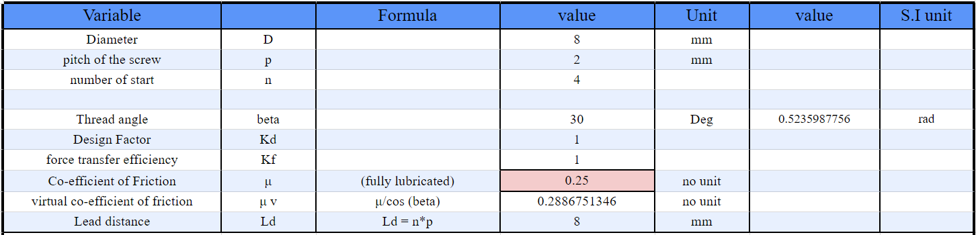

**OUTPUT PARAMETERS - LOAD:**

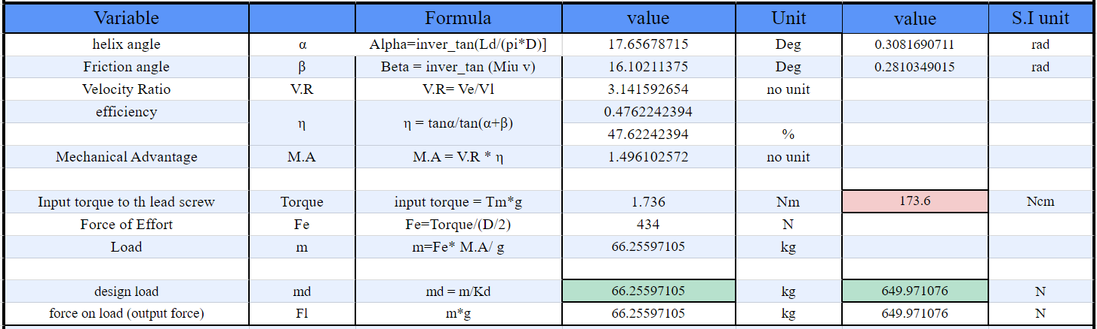**Table 4.2 Lead screw parameters (load)**

**OUTPUT PARAMETERS - MOTOR PARAMETERS:**

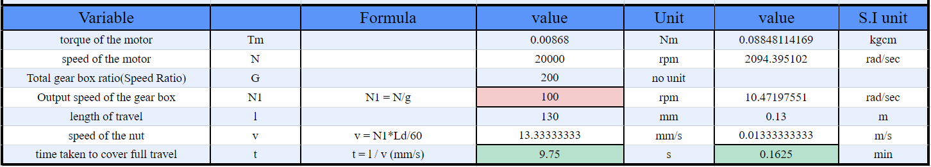**Table 4.3 Motor parameters (output)**

Considering the required force, speed of operation, cost,  mechanical advantage, available space.

* + **4-start Trapezoidal (T-8**) Over-hauling lead screw is selected.
  + **Spur gear reverted gear** train is used for getting required reduction ratio and torque from the motor.
  + Input torque and speed - **1.736 Nm @100 RPM**
  + Efficiency - **47.62%**
  + Output force - **650 N**
  + Speed - **0.013 m/s**
  + Mechanical Advantage - **1.496**
  + Time to Taken complete 1 stroke - **9.5 Second (or) 0.162 Minute**

**4.3 SELECTION OF MOTOR:**

Considering the required Torque, Speed of operation, Maximum Power, Current, Voltage, Cost, and Available Space the motor is selected.

The torque and speed of operation of the motor output shaft are taken from the above leadscrew calculation table.

**4.3.1 PRISMATIC ACTUATOR MOTOR**

100 rpm motor is used to get the desirable speed of the stroke of 13mm/s with T8 4 start trapezoidal lead screw.

* Motor - **Orange 555 Permanent magnet DC-Motor with eccentric gearbox**
* Motor Speed - **20,000 rpm**
* Output Shaft Speed - **100 rpm**
* Motor Torque - **0.00868 Nm**
* Output Shaft Torque - **1.736 Nm**
* Encoder - **OE 37 quadrature encoder**, PPR = 28 , CPR = 7

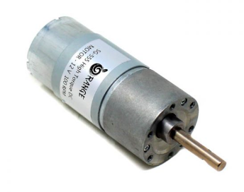

**Figure 4.1 Orange 555 Permanent magnet DC-Motor**

**4.3.2 REVOLUTE ACTUATOR MOTOR**

4 rpm motor is used to get the desirable speed as the output shaft is directly connected to the Revolving link.

* Motor - **Orange 555 Permanent magnet DC-Motor** with rectangular gearbox
* Motor Speed - **18,000 rpm**
* Output Shaft Speed - **4 rpm**
* Motor Torque - **0.00197 Nm**
* Output Shaft Torque - **8.878 Nm**
* Encoder - **OE 37 quadrature encoder**, PPR = 28 , CPR = 7

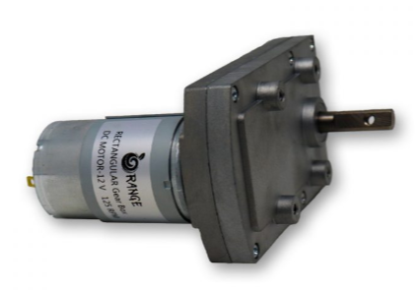

**Figure 4.2 Orange 555 Permanent magnet DC-Motor**

**GEAR TRAIN FOR PRISMATIC JOINT**

* Reverted gear train (axes of first and last gear are co-axial) is selected to meet up the torque requirement and it occupies less space.
* Reduction ratio of 200 :1 had been selected.
* Input Speed to the gearbox - 20000 rpm
* Input Torque to the gearbox - 0.00868 Nm
* Torque after reduction - 1.736 Nm
* Speed after reduction - 100 rpm
* Speed of Lead Screw travel - 13 mm/s (or) 0.78 m/min

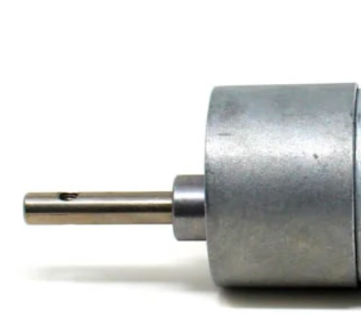

**Figure 4.3 Reverted gear train**

**GEAR TRAIN FOR REVOLUTE JOINT**

* Planetary gear train (axes of first and last gear are co-axial) is selected to meet up the torque requirement.
* Reduction ratio of 4500 :1 had been selected.
* Input Speed to the gearbox - 18000 rpm
* Input Torque to the gearbox - 0.00197 Nm
* Torque after reduction - 8.878 Nm
* Speed after reduction - 4 rpm
* Speed of revolute joint - 4 rpm or 24 Deg/s

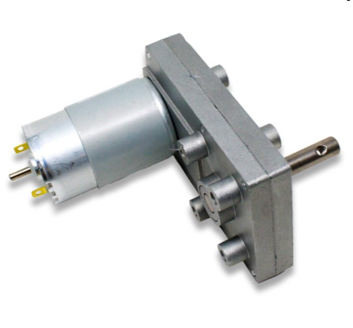

**Figure 4.4 Planetary gear train**

**DESIGN DECISIONS**

* 8mm LM Guide Rods are used for constrained prismatic motion.
* Bushes with Drilled and Reamed holes are used as linear bearings.
* T8 4-start Lead Screw of 48% efficiency is used for linear actuation with 1.73Nm torque PMDC geared motor operating at 100 RPM
* Gimbal actuation is provided by an 8.878 Nm Geared PMDC motor operating at 4 RPM.

**4.4. DESIGN PARAMETERS:**

**Table 4.4 Design parameters of the parallel manipulator**

|  |  |  |
| --- | --- | --- |
| **Weight particulars** | **Dimensions** | **Unit** |
| Overall Dimensions | 130*130*850 | mm*mm*mm |
| Weight | 5.855 | kg |
| Payload | 0.25 | kg |
| Payload Dimension | 40*40*60 | mm*mm*mm |
| Speed Of Operation | 13 | mm/s |
| Service Life | 500 | hour |
| Accuracy | +/-10 | mm |
| Precision | +/- 10 | mm |
| Lead screw design load | 650 | N |
| Lead screw design speed | 13.333 | mm/s |
| Full stroke time | 9.5 | s |
| Stroke Length | 120 | mm |
| Prismatic Motor Gear Reduction Ratio | 200:1 | No Unit |
| Prismatic Motor Torque with Gear reduction | 1.736 | Nm |
| Prismatic Motor Speed with Gear reduction | 100 | rpm |
| Revolute Gear Reduction Ratio | 4500:1 | No Unit |
| Revolute Prismatic Motor Torque with Gear reduction | 8.878 | Nm |
| Revolute Prismatic Motor Speed with Gear reduction | 4 | rpm |

**4.5 FINAL CAD MODEL:**

The CAD model is designed using Autodesk Inventor.

**Figure 4.5 Final CAD Assembly**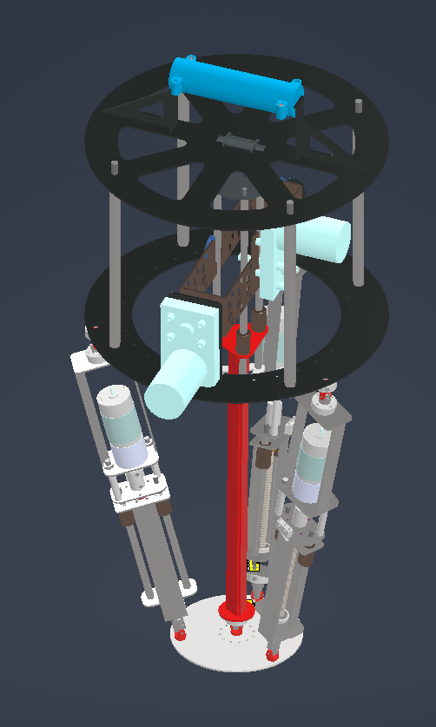

**ACTUATOR SUB-ASSEMBLY :**

**Figure 4.6 Actuator sub-assembly**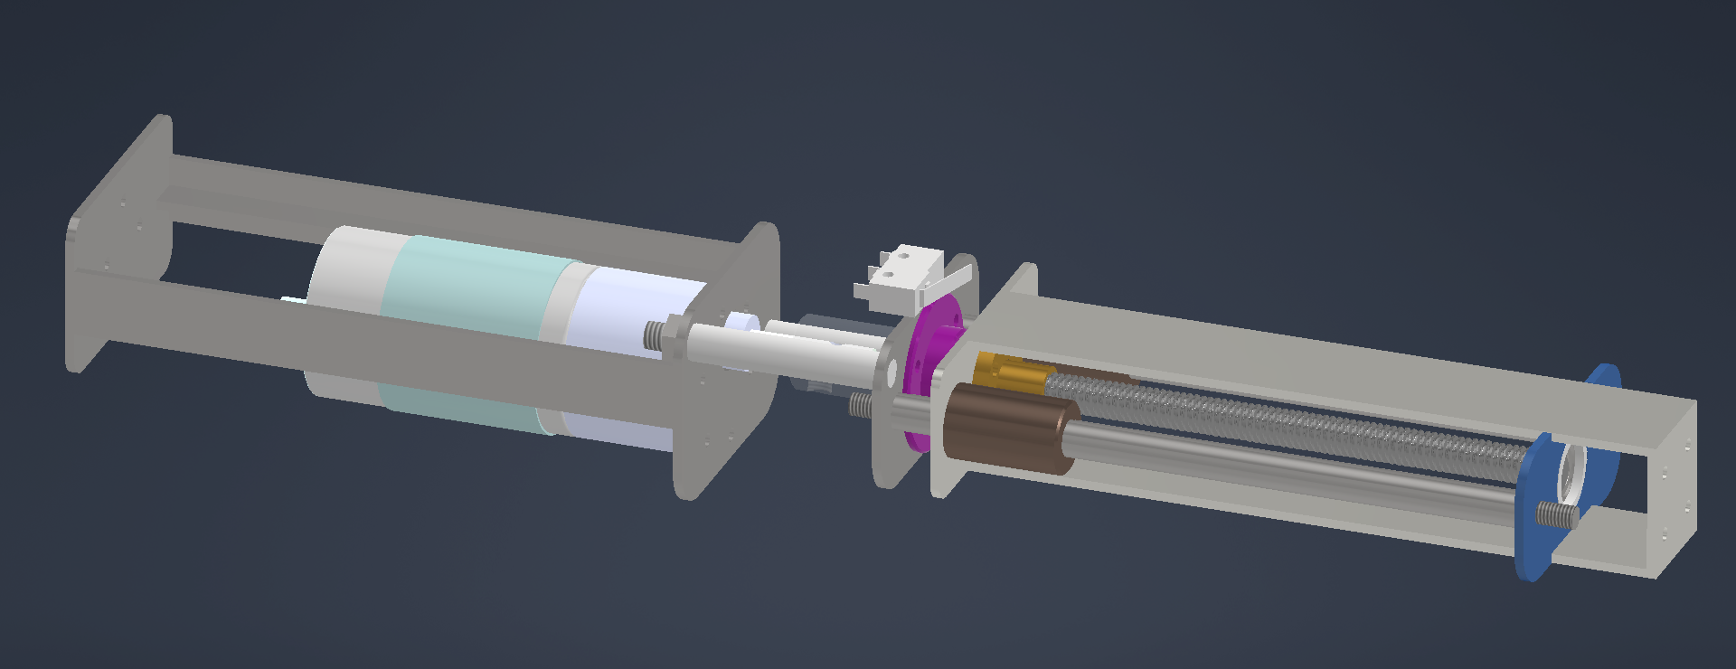

**GIMBAL SUB-ASSEMBLY**

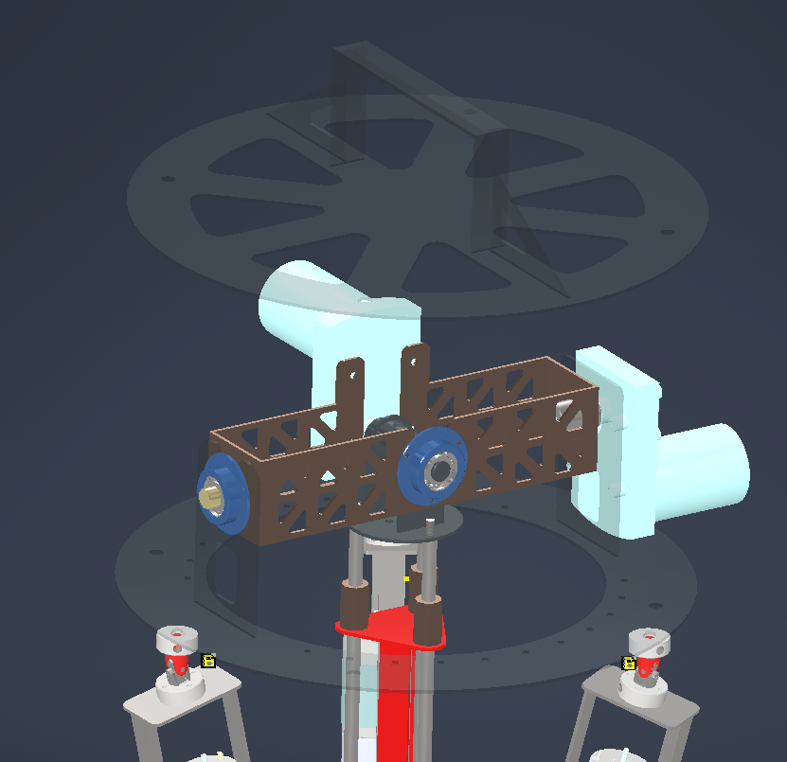

**Figure 4.7 Gimbal sub-assembly**

**PLATFORM SUB-ASSEMBLY**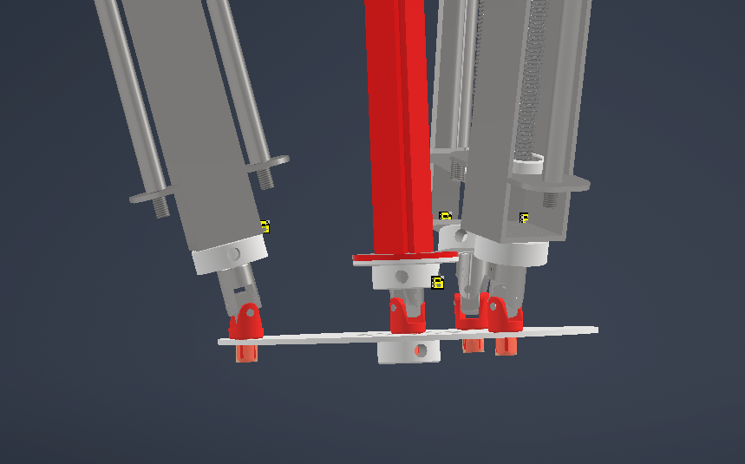

**Figure 4.8 Platform sub-assembly**

**CHAPTER 5**

**ANALYSIS AND SIMULATION PHASE**

**5.1 VALIDATION OF CHOSEN CONFIGURATION USING INVENTOR DYNAMIC SIMULATION:**

**3-UPS + 2-RR + Centre UPU(Unactuated) - (8th iteration)**

* Dynamic Simulation is done using Autodesk Inventor Dynamic Environment.
* The joints between all the links in the assembly are defined.
* The Assembly is subject to a force of 1000 N acting in the direction of the gravity.
* Reaction Forces are developed at the corresponding joints restricting the oscillation of the robot.
* Hence proves that the bot has 5 - DOF’s and constrained motion can be achieved in all the 5-DOF’s.
* Thus the Oscillation problem was solved.

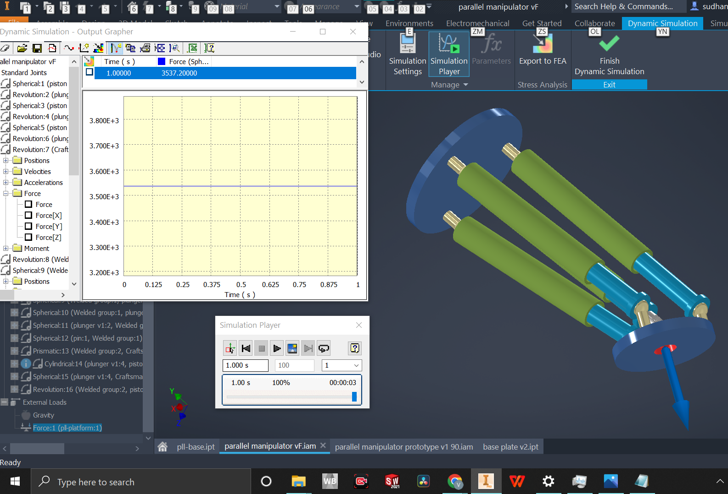

**Figure 5.1 Dynamic simulation using inventor**

**5.2 FINITE ELEMENT ANALYSIS:**

* Finite element analysis is a theoretical way of analysing the behaviour and characteristics of a material or geometry. Here life-size models of an object are considered and then divided into small elements based on the requirements.
* These elements have certain points which are located on the boundaries of an element that forms a polygon known as the nodal equation which provides the basic information such as degrees of freedom, force applied, and deformation.
* The results of these elements are interpolated and combined together to find the effect of applied force on the entire object, known as meshing.
* The meshed model is analysed by conducting structural analysis; all the previously mentioned processes can be carried out in INVENTOR STRESS ANALYSIS WORKBENCH which runs a simulation to provide us real-time data of the deformations and rate of convergence for the tested structure and material.

**5.3 MESH DETAILS:**

* The combined meshed model of the UV-joint Sub-Assembly has 66553 elements with 101301 nodes.
* The combined meshed model of the X-Tilting Bracket Sub-Assembly has 37154 elements with 18064 nodes.
* The combined meshed model of the Y-Tilting Bracket Sub-Assembly has 47653 elements with 26510 nodes.
* The combined meshed model of the Actuator Sub-Assembly has 23346 elements with 12275 nodes.
* The combined meshed model of the Base Plate Sub-Assembly has 22709 elements with 11949 nodes.

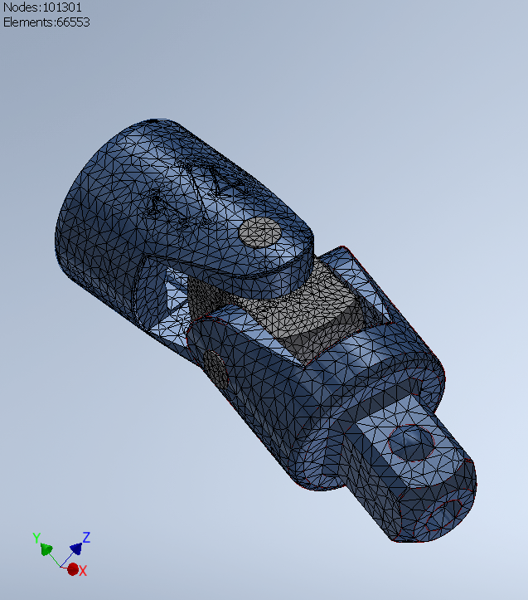

**Figure 5.2 : Meshed view of UV joint**

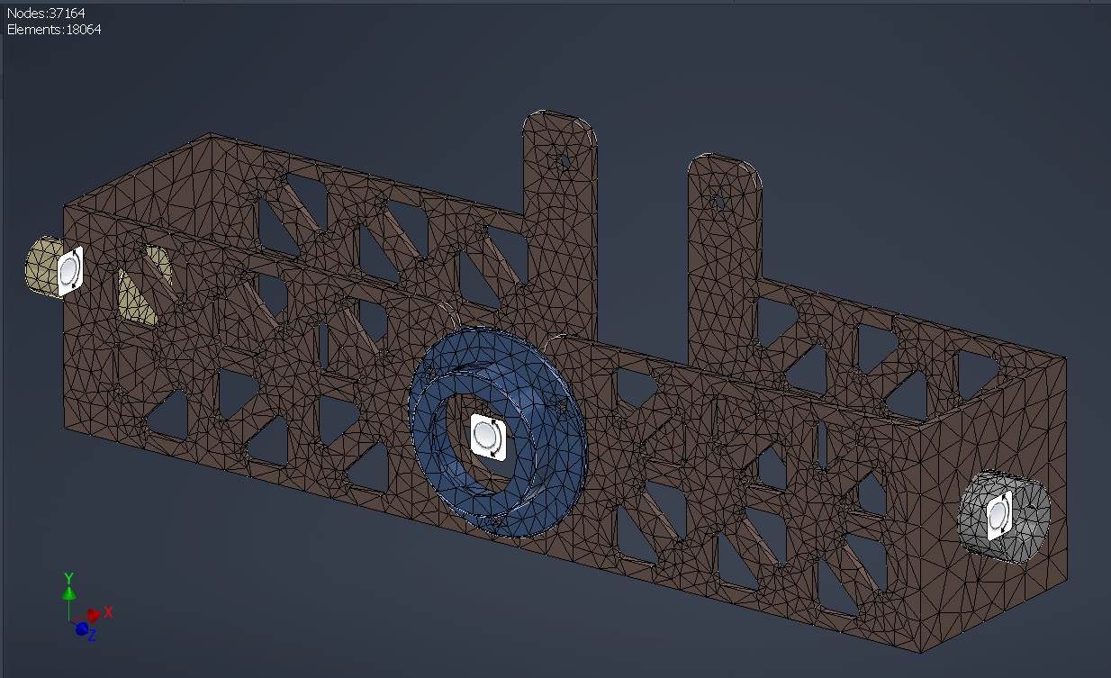

**Figure 5.3 : Meshed view of x-tilting bracket**

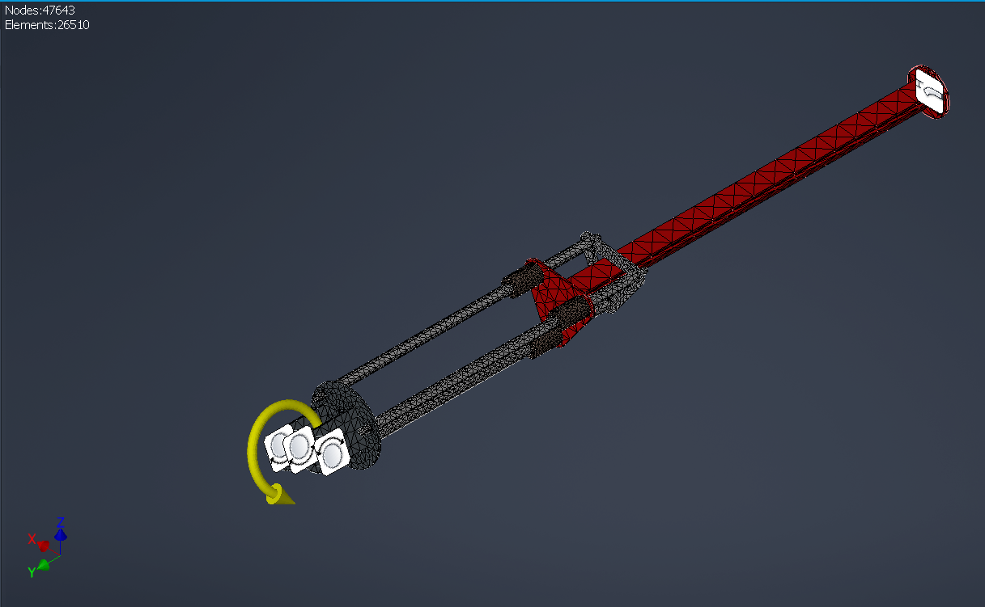

**Figure 5.4 : Meshed view of y-tilting bracket**

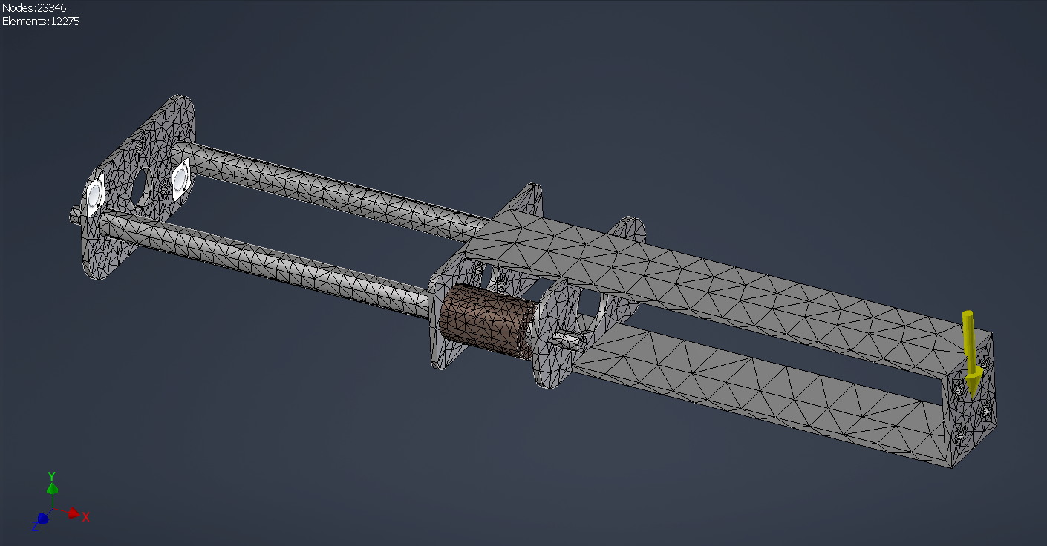

**Figure 5.5 : Meshed view of actuator**

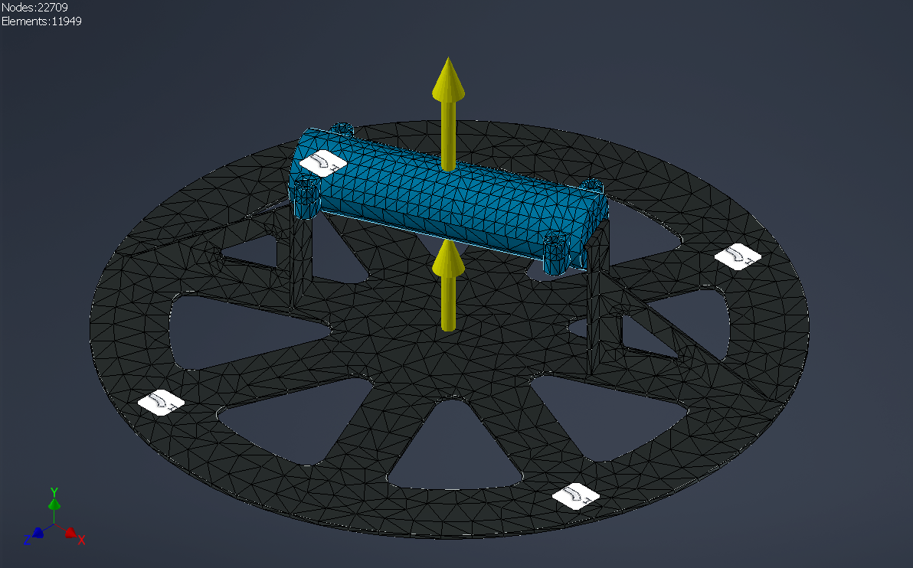

**Figure 5.6 : Meshed view of base plate**

**5.4 ANALYSIS OF STRUCTURAL COMPONENTS**

Considering the,

* Von-mises (Maximum Distortion energy),
* Tresca (Maximum Shear stress),
* Rankine (Maximum Normal stress),

theory of failure, and selection of suitable materials and geometry as per the stresses calculated.

**5.4.1 UV-JOINT SUB-ASSEMBLY:**

**MATERIAL -** ASTM 4340 Steel

**LOAD -** 80 N (Axial Load)

**BOUNDARY CONDITION -** Fixed At one end

**CONTACTS -** Sliding without separation

The UV joint is subjected to 80N of axial load with the boundary condition fixed at one end, The material considered is ASTM 4340 Steel (Nickel Chromium Steel), The contacts are taken as sliding without separation contacts. The mesh average size is given as 0.1 mm and the minimum is 0.005 mm. The maximum von Mises stress obtained is 59.17 MPa giving rise to a factor of safety of 7.943 for the maximum distortion energy (Von Mises) theory of failure, The maximum Normal stress obtained is 81.56 MPa and the factor of safety of 5.762, The maximum displacement obtained is 0.2374 mm.

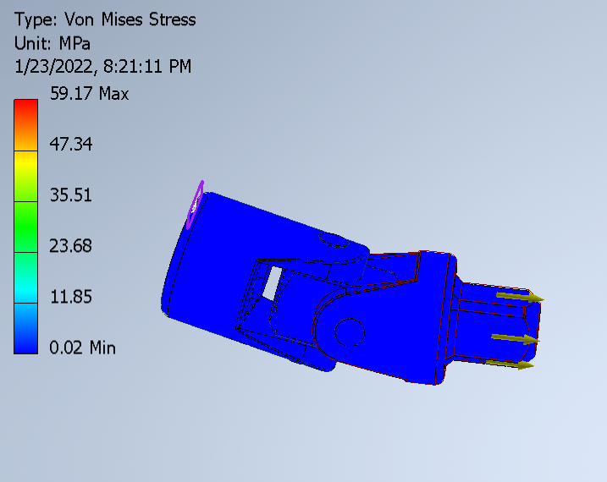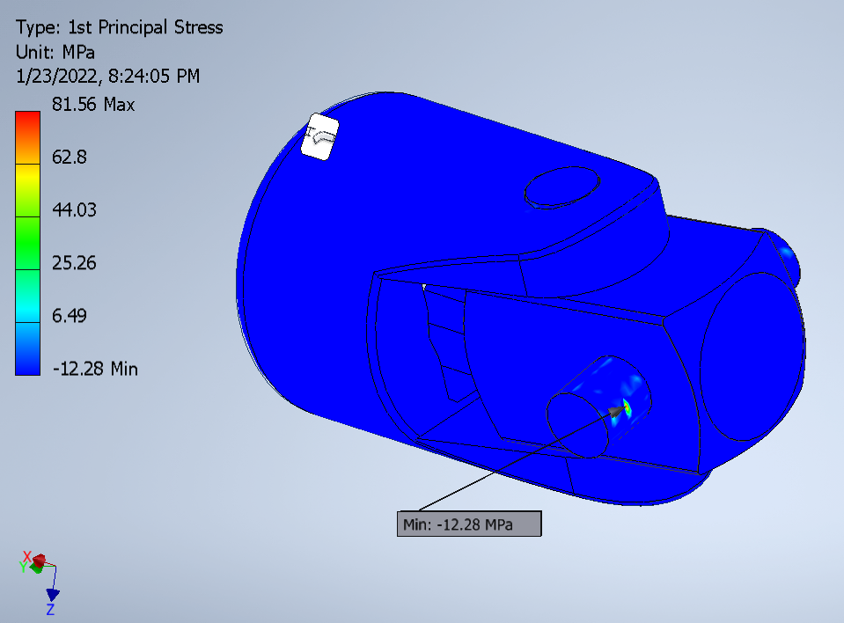

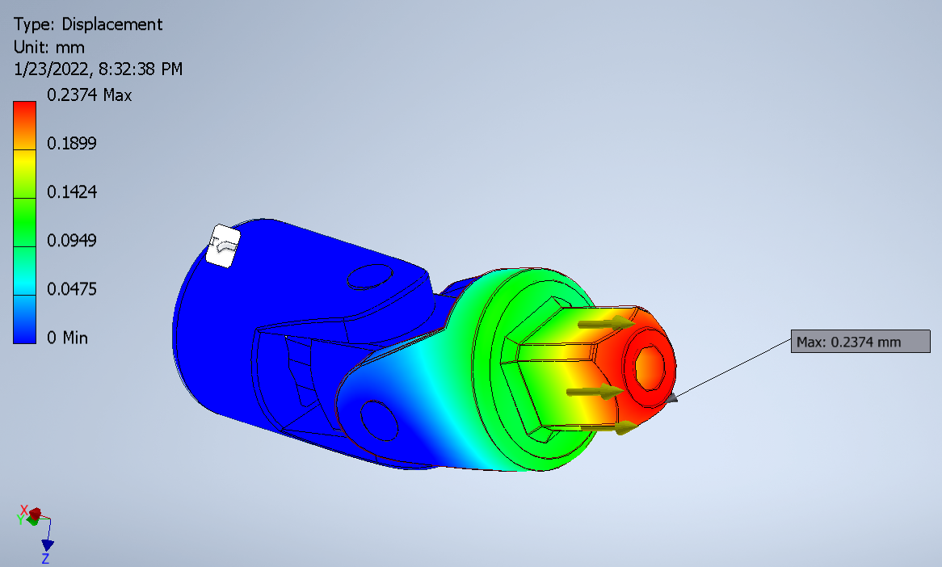

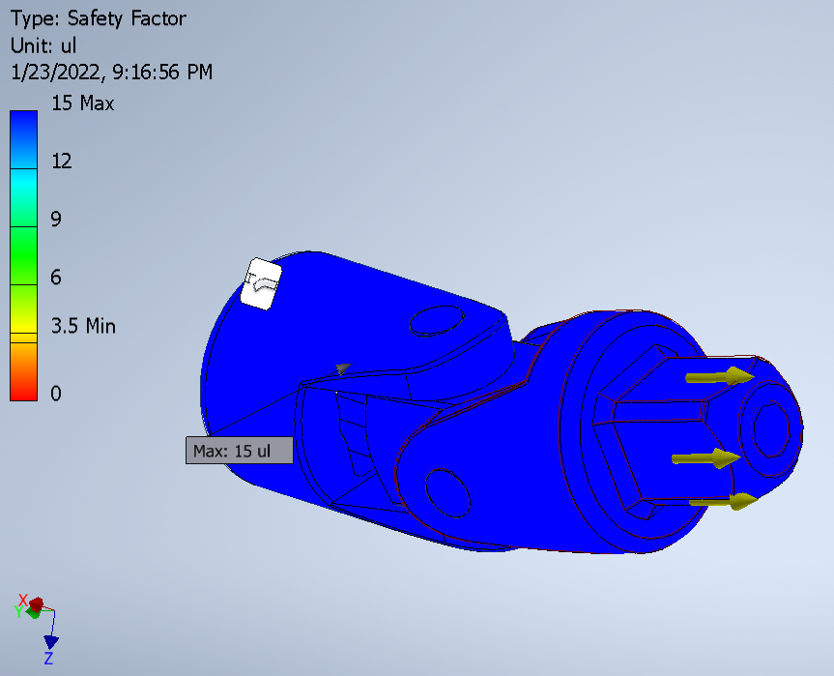

**Figure 5.7 Mesh analysis of UV joint**

**5.4.2 X-TILTING BRACKET SUB-ASSEMBLY:**

**MATERIAL -** Mild Steel

**LOAD -** 9 Nm Moment from motor’s peak torque

**BOUNDARY CONDITION -** Cylindrical support at the bearing supported faces.

**CONTACTS -** Bonded

The X-Tilting Bracket Sub-Assembly is subjected to 9Nm of moment load with the boundary condition cylindrical support at the bearing supported faces, The material considered is mild steel, The contacts are taken as bonded. The mesh average size is given as 0.5 mm and the minimum is 0.05 mm. The maximum von Mises stress obtained is 93.71 MPa giving rise to a factor of safety of 2.21 for the maximum distortion energy (Von Mises) theory of failure, The maximum Normal stress obtained is 96.72 MPa and the factor of safety of 2.19, The maximum displacement obtained is 0.197 mm.

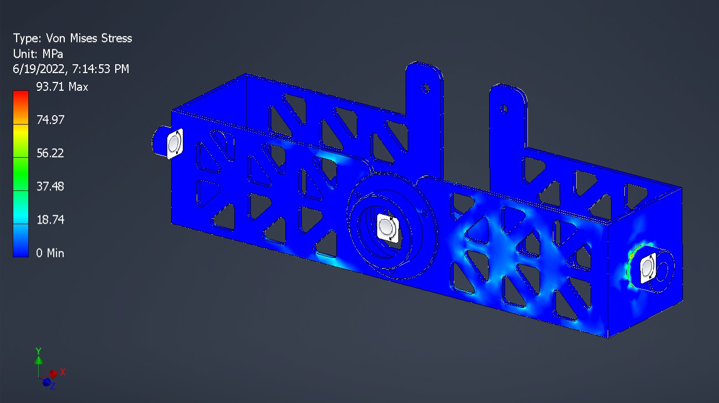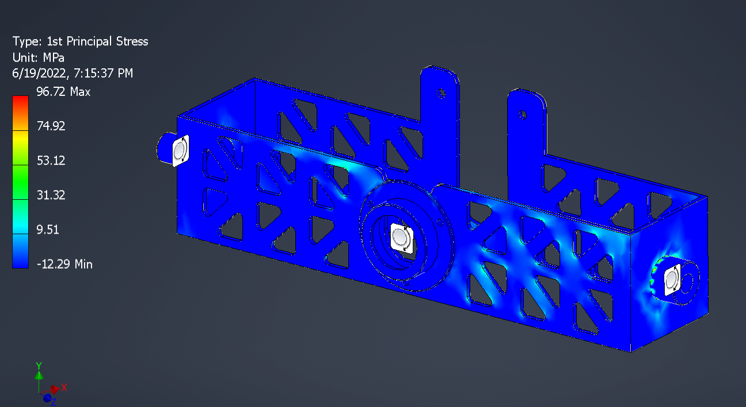

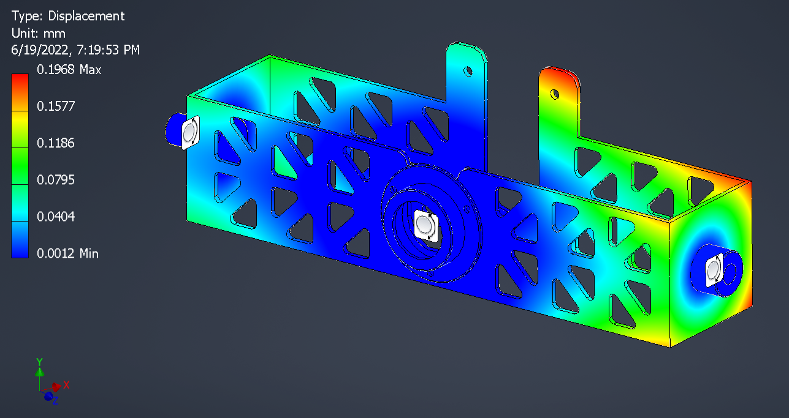

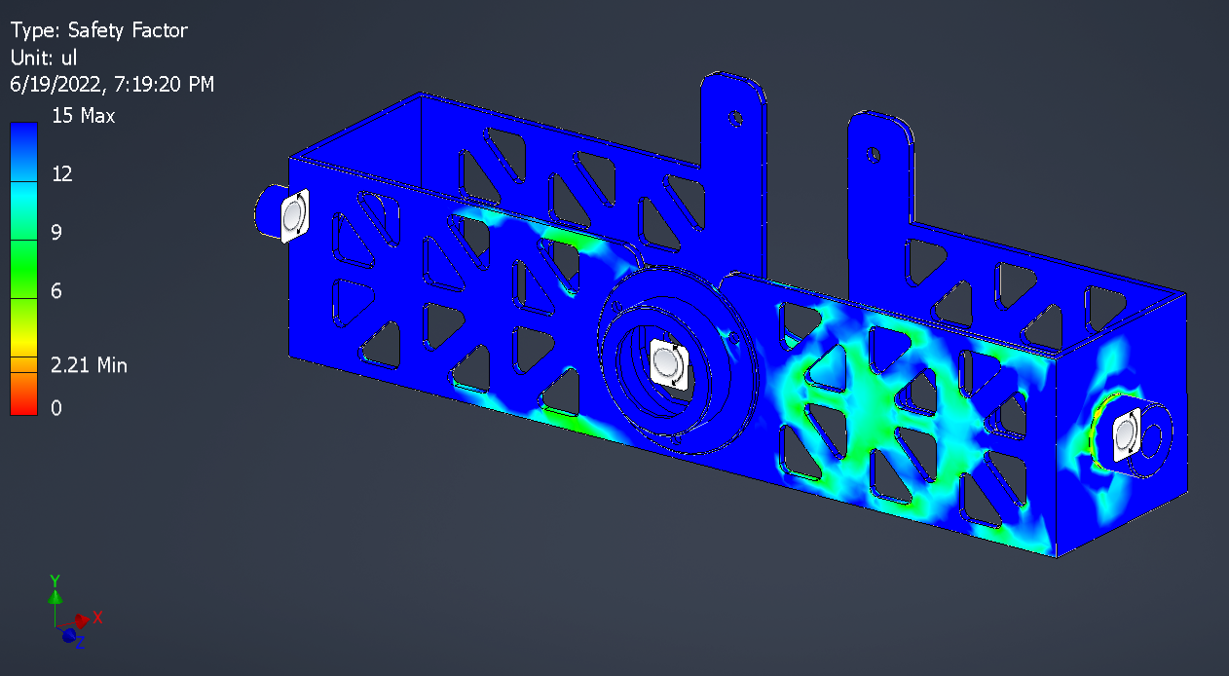

**Figure 5.8 : Mesh analysis of x-tilting bracket**

**5.4.3.Y-TILTING BRACKET SUB-ASSEMBLY:**

**MATERIAL -** Mild Steel

**LOAD -** 9 Nm Moment from motor’s peak torque

**BOUNDARY CONDITION -** Cylindrical support at the bearing supported faces, fixed support at one end.

**CONTACTS -** Bonded

The Y-Tilting Bracket Sub-Assembly is subjected to 9Nm of moment load with the boundary condition cylindrical support at the bearing supported faces, fixed support at one end, The material considered is mild steel, The contacts are taken as bonded. The mesh average size is given as 0.5 mm and the minimum is 0.05 mm. The maximum von Mises stress obtained is 66.2 MPa giving rise to a factor of safety of 3.13 for the maximum distortion energy (Von Mises) theory of failure, The maximum Normal stress obtained is 83.97 MPa and the factor of safety of 2.98, The maximum displacement obtained is 0.082 mm.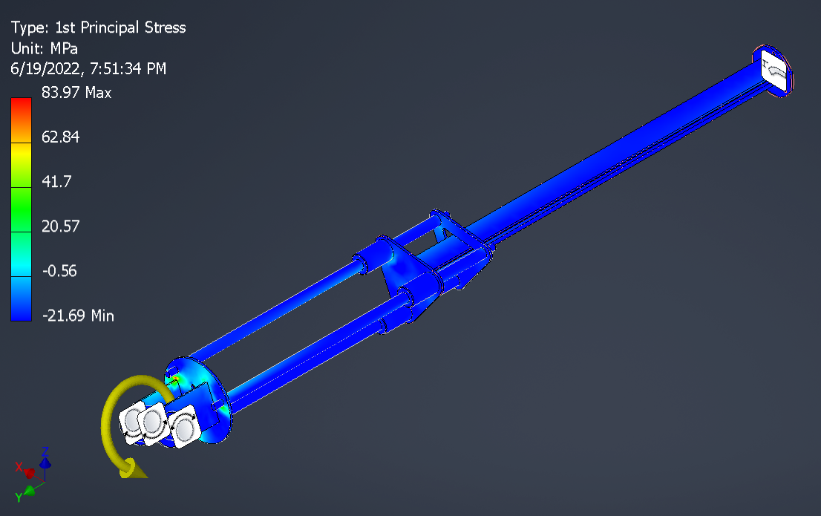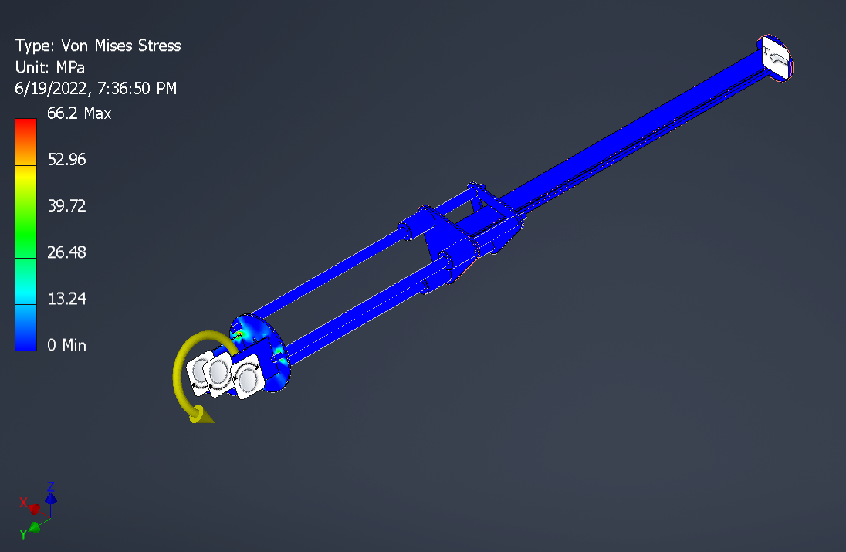

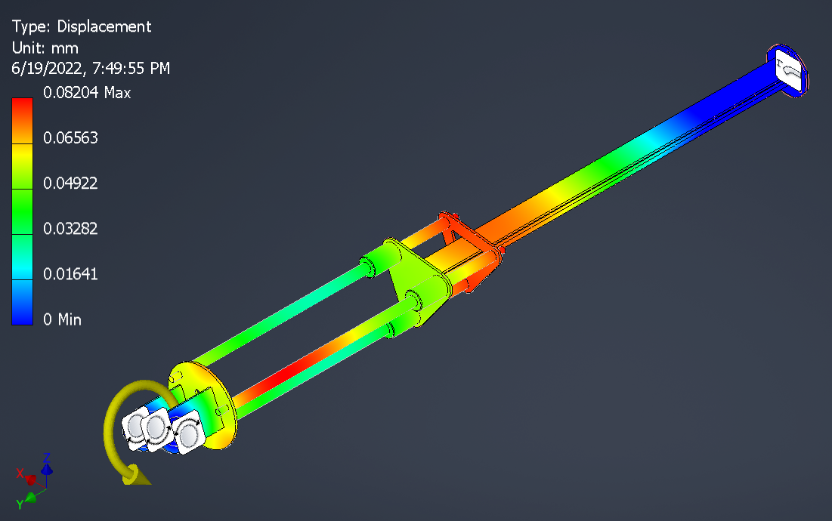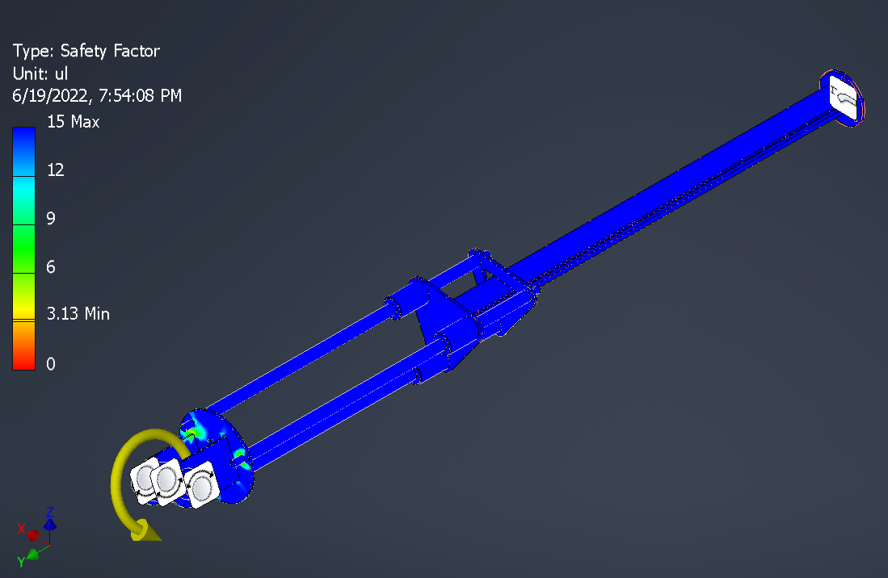

**Figure 5.9 : Mesh analysis of Y-tilting bracket**

**5.4.4 ACTUATOR SUB-ASSEMBLY**

**MATERIAL -** Mild Steel.

**LOAD -** 20 N bending load at the end.

**BOUNDARY CONDITION -** 2**-**Cylindrical supports at one end.

**CONTACTS -** Bonded.

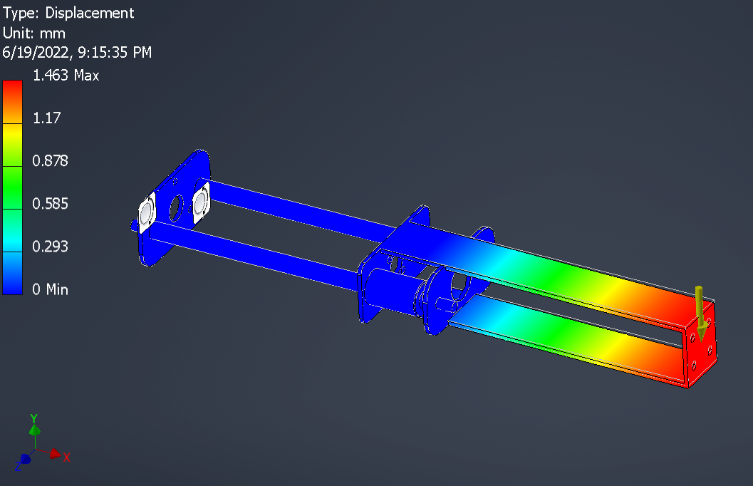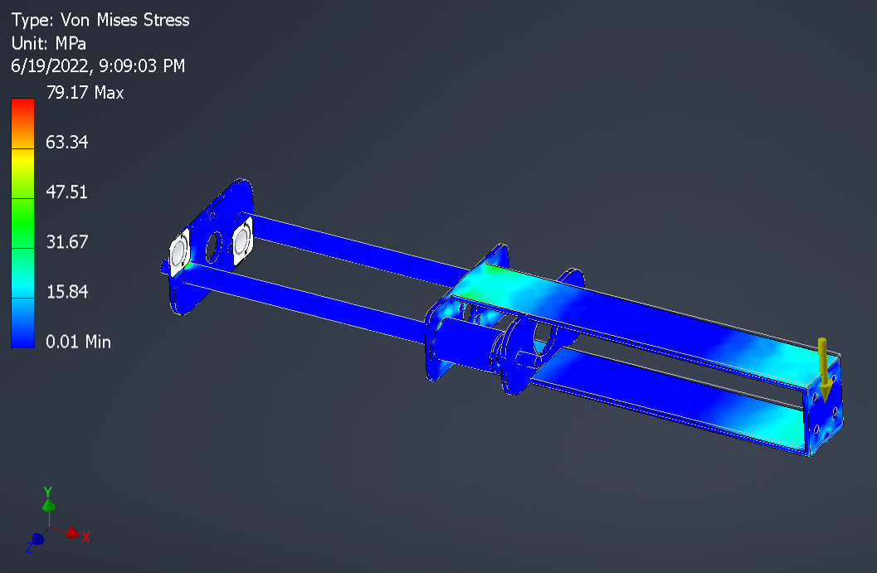The Actuator Sub-Assembly is subjected to 20 N of bending load with the boundary condition **2-**Cylindrical supports at one end, The material considered is mild steel, The contacts are taken as bonded. The mesh average size is given as 0.5 mm and the minimum is 0.05 mm. The maximum von Mises stress obtained is 79.17 MPa giving rise to a factor of safety of 2.61 for the maximum distortion energy (Von Mises) theory of failure, The maximum Normal stress obtained is 101.2 MPa and the factor of safety of 2.47, The maximum displacement obtained is 1.46 mm.

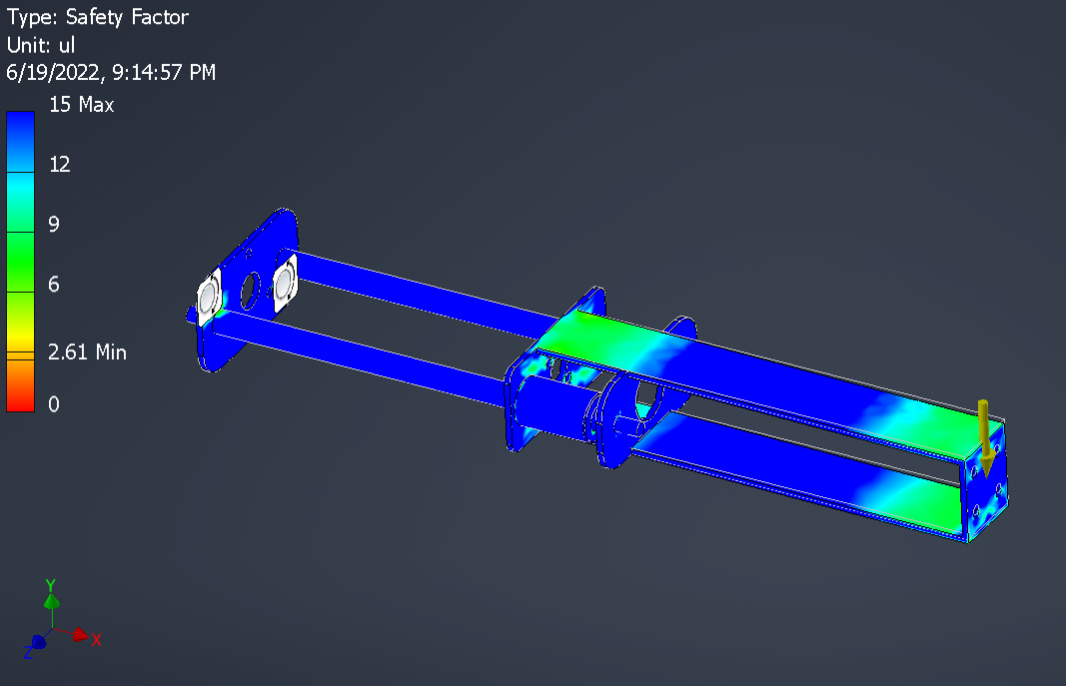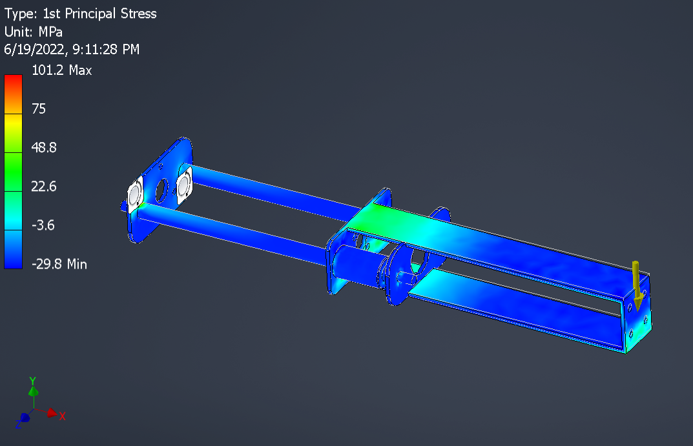

**Figure 5.10 : Mesh analysis of actuator sub-assembly**

**5.4.5 BASE PLATE SUB-ASSEMBLY**

**MATERIAL -** Mild Steel.

**LOAD -** 150 N for load at the handle.

**BOUNDARY CONDITION -** fixed support at 4 points.

**CONTACTS -** Bonded.

The Base Plate Sub-Assembly is subjected to 150 N for load at the handle, fixed support at 4 points, The material considered is mild steel, and the contacts are taken as bonded. The mesh average size is given as 0.5 mm and the minimum is 0.05 mm. The maximum von Mises stress obtained is 60.46 giving rise to a factor of safety of 3.42 for the maximum distortion energy (Von Mises) theory of failure, The maximum Normal stress obtained is 88.07 MPa and the factor of safety of 2.83, The maximum displacement obtained is 0.29 mm.

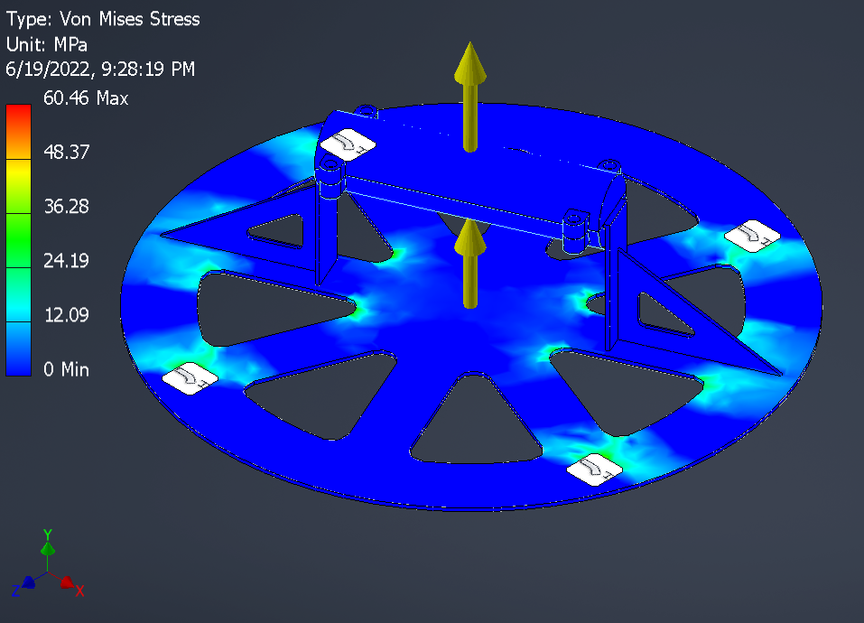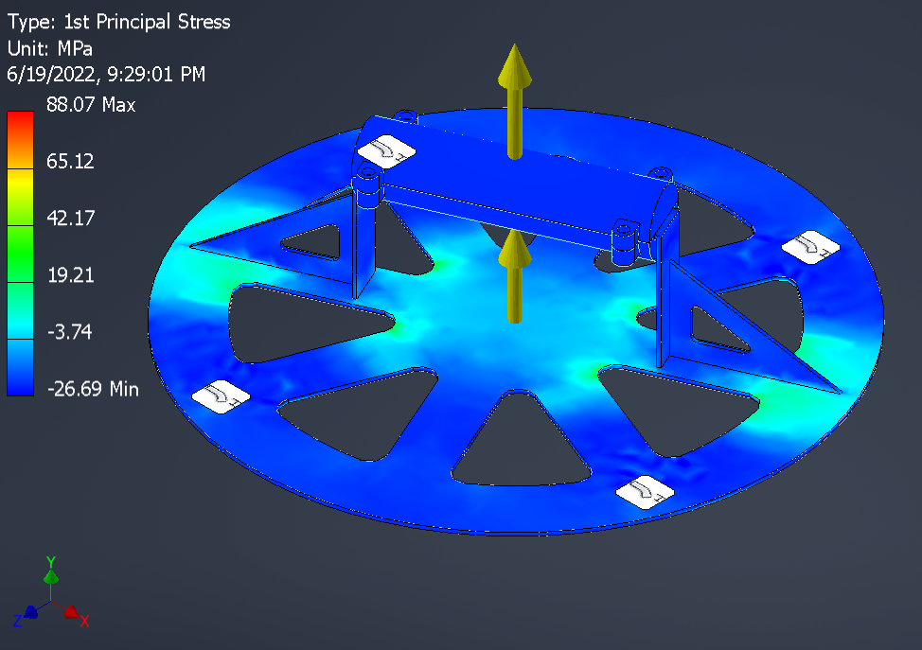

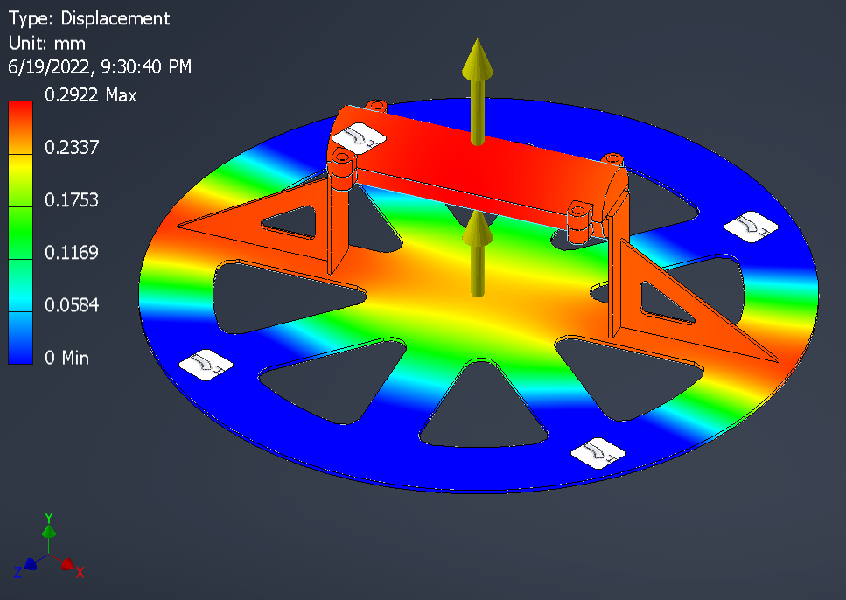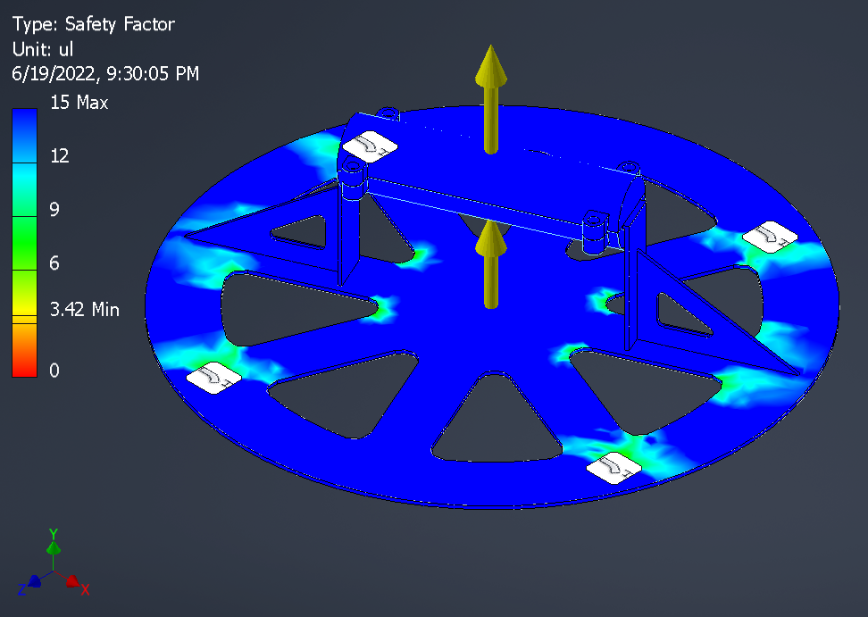

**Figure 5.11 : Mesh analysis of base plate sub-assembly**

All the key components subjected to heavy loading are analysed and thus it is confirmed that the maximum stress in the member is at least 2 times smaller than the yield strength of the material considered. Thus, all the components are safe. The components are also checked for large displacement. Since, large displacements could be highly undesirable as it could reduce the accuracy and precision of the manipulator.

**CHAPTER 6**

**FABRICATION PHASE**

**6.1 MANUFACTURING TECHNIQUES**

● FDM 3D-printing,

● SLA 3D-printing,

● Milling,

● Turning,

● Broaching,

● Grinding,

● Laser Cutting

● TIG Welding

● Brazing

**MATERIAL USED**

**PLA (Polylactic Acid)**

PLA is a user-friendly thermoplastic with higher strength and stiffness than both ABS and nylon. With a low melting temperature and minimal warping, PLA is one of the easiest materials to 3D print successfully. Unfortunately, its low melting point also causes it to lose virtually all stiffness and strength at temperatures above 50 degrees Celsius. But PLA is brittle, leading to parts with poor durability and impact resistance. It is the most printable and cheapest among all filaments used for 3d printing hence we selected PLA as our Structural material.

**MILD STEEL**

* High impact strength
* High tensile strength
* Good ductility and weldability
* A magnetic metal due to its ferrite content is able to fix.
* Good malleability with cold-forming possibilities
* Not suitable for heat treatment to improve properties
* unparallel weldability and machinability.

**6.2 ASSEMBLY TECHNIQUES**

* + - * Snap fits
      * Loose running Fits
      * Adhesives
      * Threaded Fasteners

**6.3 FABRICATED MODEL**

Full assembly Prototype -1 (Iteration - 4)

Full assembly Prototype - 2 (Iteration - 6)

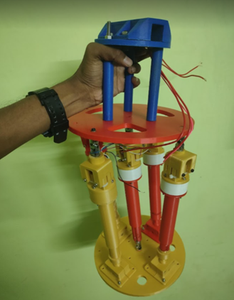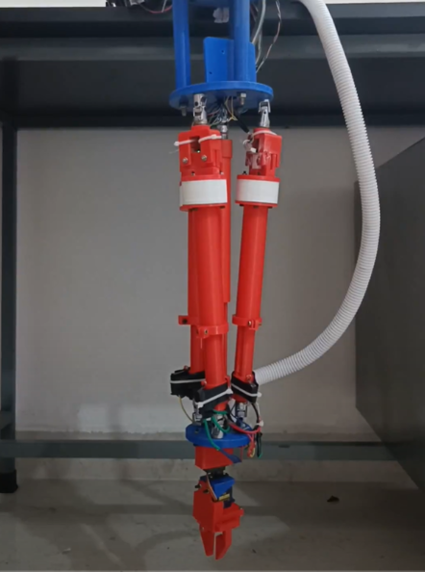

**Figure 6.1 prototype 1 Figure 6.2 Prototype 2**

**METAL FABRICATION OF PROTOTYPE – 3**

**Manufacturing Technique - Metal Fabrication (using Mild Steel)**

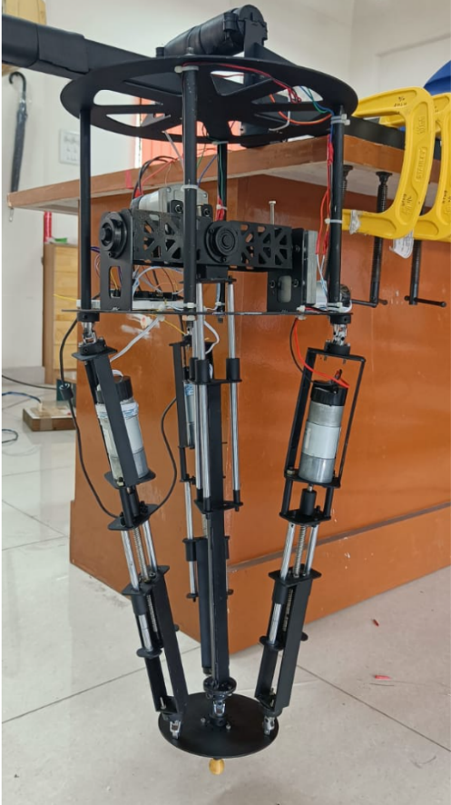This technique integrates materials, structures, and functions. Laser cutting is used to form the different structures. Welding is used to forming the complex parts by the permanent assembly of the laser cut plates. Guides are used as guides for easy welding and assembly. Lathe Machining and Milling operation is used to form the revolved parts and form PCD through and threaded holes. LM hardened Nickel chromium steel rods are used for smooth sliding of the prismatic joint. Flanges with drilled and reamed hollow bushing as linear bearing that slides through the Lm guide Rods. ¼ inch standard socket driver UV joints are used. Brazing is used for rigid assembly of parts made of different metals (LM guide rods and mild steel base plates). TIG Welding is used for the rigid assembly of complex parts and is used to minimize warping as the parts are very thin and slender.

**Figure 6.3 Prototype 3**

**CHAPTER 7**

**RESULT AND CONCLUSION**

Today, the industrial world 4.0 has been revolutionized with automation where the use of robotics has increased enormously. Here, the **Parallel Manipulator** has been designed, analysed, and fabricated with the material PLA (**POLYLACTIC ACID)** for the initial iterations, and after the design idea was confirmed, the material used was **Mild Steel** with a payload capacity of 0.25 kg and is inspected working with the code (python).

Through this project, we identify that the manipulator (robot) did achieve the expected 5 degrees of freedom as expected, and an additional 6 degrees of freedom can be added by adding a separate motor on the base platform.

From the progress and findings in the mini-project we had the following issue. After the bot was assembled and actuated the centre link was found to be varying despite all other actuators being at rest. This is thought to be the speculated reason for the manipulator not achieving all the degrees of freedom. Hence in the next iteration, the center link was controlled using another actuator to ensure the link stays at a controlled length but this did little to no benefit in terms of movement. Hence the next step was to build the manipulator with **4 UPS and 1 UPU** active link which also didn't show any improvement in terms of the control or the performance of the movement along 3 degrees of freedom. At this point, we were sure that the manipulator was under-actuated and needed **5 actuators** to achieve all **5 degrees of freedom**. Hence, the final iteration involved using an active gimbal-like arrangement to control the angle of the center link while keeping the prismatic actuation passive ( not directly controlled by the user).

This final iteration was able to solve all the above-mentioned issues that is the control over degrees of freedom and accuracy of operation. Hence this model was considered to be the optimal one of all the previous iterations.

**FUTURE SCOPE**

* Using the knowledge obtained from the previous works, a full-scale parallel manipulator which could carry 20kg load is designed and manufactured.
* It can be designed to be employed in the borewell child rescue system.
* It can be designed to be employed in the manhole scavenging system.
* It can be designed to be employed in the metrology lab for accurate positioning of the workpiece for laser interferometry measurement devices.
* It can be designed to be employed in the metrology lab for accurate positioning of the CMM probe.
* It can be designed to be employed in the assembly of the parts.
* It can be designed to be employed in 6-Axis milling and surface grinding.
* It can be designed to be employed in flight simulators.
* It can be designed to be employed in VR gaming simulators.
* It can be designed to be employed in industrial pick and place applications.
* It can be used for supper smooth stabilization of high-speed cameras

**REFERENCES**

Many researchers had performed various experimental investigations on series and parallel manipulators each with various load lifting capacities and axes of legs required. There are many types of manipulators where we require an in-depth study of kinematics, stress and force analysis and the number of legs (axes) required considering the factor of safety.

1. Andreas Aristiton and Joan Lasenby, University of Cambridge (2009) - “INVERSE KINEMATICS: a review of existing techniques and introduction of a new fast iterative solver”, pp 6 - 9.

2. JEAN PIERRE MERLET, National Institute for Research in Computer Science and Control Sophia-Antipolis (January 1994) - “Direct kinematics of parallel manipulators”, IEEE Transactions on Robotic and Automation, pp 3 – 6.

3. Panchanand JHA, National Institute of Technology, Rourkela, India (2007) - “Inverse Kinematic Analysis of Robot Manipulators”, pp. 5 - 8, 11 - 13, 38 - 40.

4. V.Parenti-CASTELLI, R.Di Gregorio and F.Bubani, Ferrara, Italy (Received: 8 February 2000; accepted in revised form: 21 June 2000) - “Workspace and Optimal Design of a Pure Translation Parallel Manipulator”, pp. 12 - 18, 37 - 39.

5. Maira Martin Silva, University of PAILA (2014) T”orque Optimisation  of Parallel Manipulators by the Application of Kinematic Redundancy”. pp. 4-8.